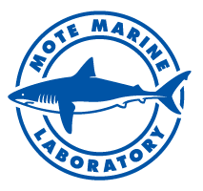

Entangled dolphin calf rescued near Clearwater

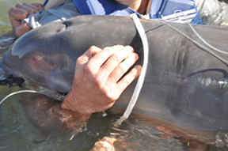

A dolphin calf entangled in fishing line and plastic debris. Credit: National Marine Fisheries Service.
All photos taken under NOAA Permit #18786.

A bottlenose dolphin calf estimated to be about 6-months-old is now safely swimming with her mom after rescuers freed her from life-threatening plastic debris and fishing lines caught around her body. The rescue took place Thursday morning, Oct. 15, off the west coast of Florida, near Clearwater.
The calf was first reported by a boat captain to National Marine Fisheries Service’s partner Clearwater Marine Aquarium (CMA) staff on Oct. 6. Boaters in the area around the Caladesi Island and Dunedin Causeway were notified via VHF radio to be on the lookout for the calf.
Once reports of sightings came in, NMFS organized a rescue team led by the Sarasota Dolphin Research Program (SDRP), a collaboration between Mote Marine Laboratory and the Chicago Zoological Society (CZS), and including collaborating biologists and veterinarians from Mote, CMA (who also provided most of the boats for the rescue), the Florida Fish and Wildlife Conservation Commission, the University of Florida, SeaWorld Orlando and NMFS, and an experienced net fisherman.
Accompanied by law enforcement vessels, the 37-person rescue team left the dock in Clearwater on five boats at about 8:30 a.m. Thursday, and by 10:21 a.m. the veterinarians and biologists had caught the calf, removed the entanglements, examined her and determined that she had no major injuries and would be able to be released with her mother. Dr. Randy Wells, Director of the Sarasota Dolphin Research Program, clipped a small tag to the calf’s dorsal fin, which will allow monitoring of her progress now that she is free of the gear. Both animals swam off side-by-side.
“This rescue was such an incredible effort by a number of collaborating organizations,” Wells said. “Although this calf was rescued successfully, many other dolphins have not had the benefit of becoming entangled in areas where people detect the occurrence and respond with a rescue. This story serves as a reminder for people to dispose of their trash, plastic waste and fishing line appropriately.”
The team was able to remove the entangling gear before it had caused more than superficial lacerations to the calf. The gear included a ring of plastic strapping material that encircled the dolphin’s chest, with two kinds of fishing line trailing from the ring.
“If not removed, the lines and debris would likely have cut deeply into the calf and eventually killed it,” Wells said. “While this story had a happy ending, so many don't. Please dispose of trash properly. Marine debris can be deadly.”
If you see a stranded, entangled, injured or dead dolphin, whale, manatee or sea turtle anywhere in Florida, please call the FWC Wildlife Alert hotline at 888-404-FWCC (3922). For marine mammals and sea turtles in Sarasota or Manatee county waters, you can contact Mote's Stranding Investigations Program, a 24-hour response service, at 941-988-0212.

Marine debris: biodiversity impacts and potential solutions

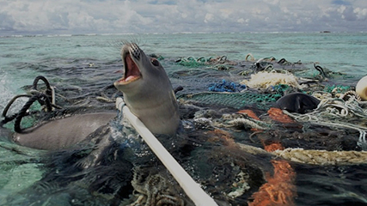

Seals, turtles, sharks and dolphins are killed by abandoned fishing nets. tedxgp/Flickr
Pollution from human activities has major impact on the world’s marine ecosystems. Plastic refuse is one of the most pervasive types of pollution.
More than 80 million tons of plastics are estimated to be produced globally each year. These plastics are durable, requiring about 500 years to decompose in the ocean. Their durability and buoyancy allows them to be carried far from their sources.

Plastic gets into the ocean, into marine species and into us
For instance, the ratio of plastic to zooplankton in the major ocean gyres, which tend to concentrate floating material, is estimated to be up to 6:1 by weight.
Whales, fish and other marine species depend on zooplankton for food, as they are the fundamental link to the phytoplankton who the capture sun’s energy. Researchers currently believe plastics are taken up by zooplankton, thus entering the food chain.
Plastics also bring toxins into the food chain. When plastics break down, they produce toxic products. They also aggregate pollutants in the environment. Both are released when animals digest the plastic.
Globally more than 200 species are known to be affected by marine rubbish including whales, seals, dugong, seabirds, turtles, crabs, seasnakes, sharks, rays and other fish.

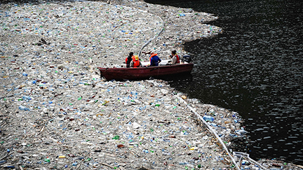

When plastics break down, they produce toxic products. tedxgp/Flickr
While many of these species are threatened, still others form part of our diet. This means that plastic ingested by wildlife not only affect them - their guts may be perforated and they may starve - but toxins from the plastics may also be absorbed by humans.

Tangled up in blue
Entanglement is also a significant threat to marine species. For example, up to 40,000 fur seals are killed each year when they get tangled in debris. This contributes to a population decline of 4-6% per year.
Entanglement affects nearly all groups of marine vertebrates. We know that in Australian waters turtles, cetaceans, seals, sea lions, seabirds, sharks and rays, crabs and other animals are affected.
Lost fishing gear and related refuse in particular is a major issue. Globally it is estimated that at least 6.4 million tons of commercial fishing gear is lost into the ocean each year.
The Gulf of Carpentaria, at the top end of Australia, provides a stunning example of this. More than 8,000 derelict fishing nets - which add up to 90,000 metres of net - have been cleaned up on beaches in the region.
Our oceanographic modelling suggests that these nets drift over large areas of the region, likely impacting six of the world’s seven marine turtle species which occur there. Many other species are probably also affected, but decay before the nets wash ashore and are found.

Where does it all come from and how did it get here?
Most importantly, despite recycling and other efforts, the problem is rapidly intensifying. Plastics production has grown 500% over the last 30 years. It is still increasing at a rate of 3-5% per year.
The amount of plastic in the environment is increasing at an exponential rate. This suggests both total volume of production and failures to appropriately dispose of plastics are contributing to plastics into the environment. Shockingly, the highest average plastic count on record is 334,271 pieces per square kilometer – and this is from a survey completed more than a decade ago.
Researchers are beginning to tackle this problem. They are trying to understand why plastics enter the environment, where they go once they are lost, and what impacts they have on marine species and ecosystems.

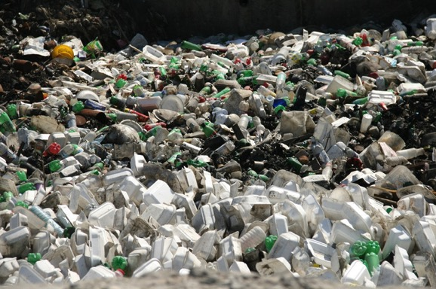

Encouraging people to recycle plastic bottles can make a real difference. tedxgp/Flickr
In our research, for instance, we are assessing the marine debris that washes up on shores around Australia. We’re comparing types of marine rubbish in urban areas versus those in remote locations to identify likely domestic versus foreign contributions to marine debris.
This work relies heavily upon the countless volunteers and community groups that conduct beach clean ups in their area. It is an excellent example of the value of citizen scientists/volunteer collected data.
We use these data with oceanographic models to track likely sources and sinks of marine rubbish through space and time. We see seasonal differences in marine rubbish washing up along the coastline, much of which is likely due to differences in ocean current patterns that differ at different times of the year. And we’re learning about what types of debris are found near urban centers (plastic bags, cigarette butts, sundry items) and in more remote areas (such as fishing gear off the west coast of Tasmania).

How can we solve the problem?
Tackling marine debris will require cultural change via a mix of education, incentives, and regulation. Plastic bottle recycling is an excellent example – it has increased every year since 1990 to 2.2 trillion pounds in 2006.
Educational tools, such as the plastics identification code on bottles, provided essential knowledge for the public and increased participation. Bottle deposits, an economic incentive, resulted in a 75% reduction in losses into the environment. Regulations, such as recent prohibitions on disposable drink bottles may further reduce the problem.
However, our lack of information makes it hard to target education, incentives and regulation. Linking plastic in the environment to particular factories, stores, fishers or consumers is currently impossible. This means that our tools for cultural change must be broadly targeted, while losses into the environment are likely due to an irresponsible minority, as in many other types of pollution.
Human behaviour needs to change from the current throwaway culture being status quo, and accountability is a fundamental ingredient in this change.

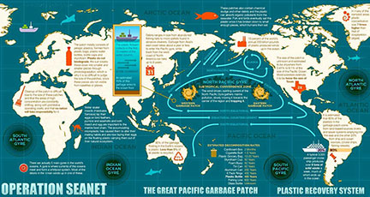

Mote President and CEO becomes SCUBAnauts International Board member

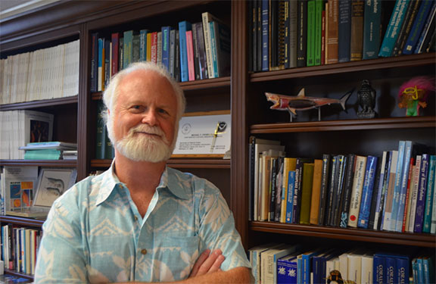

Dr. Michael P. Crosby, Ph.D., President and CEO of Mote Marine Laboratory, has joined the Board of Directors of SCUBAnauts International, which was founded by Capt. David Olson (USN, Ret) in Palm Harbor, Fla. in May of 2001 in an effort to introduce young men and women to informal science education through underwater exploration.
Crosby came to Mote following his appointments as Associate Vice President for Research and Economic Development at George Mason University, and Vice Chancellor for Research at the University of Hawai’i - Hilo. Prior to those appointments, he served in a federal Senior Executive Service position as Executive Director of the National Science Board in Washington, DC; the Senior Advisor for International Science Policy; Executive Director for the Science Advisory Board of the National Oceanic and Atmospheric Administration (NOAA); and National Research Coordinator for NOAA National Marine Sanctuaries and National Estuarine Research Reserve System.
Crosby obtained an M.S. in Biology, with honors, from Old Dominion University and a Ph.D. in Marine-Estuarine-Environmental Sciences at the University of Maryland. Crosby is currently on the Boards of, and has served as President for, several national and international science societies.
In May 2013, after serving for three years as Mote’s Senior Vice President for Research, Mote’s Board of Trustees appointed Crosby as President and CEO of Mote Marine Laboratory and Aquarium.
"I am thrilled to welcome Dr. Michael Crosby as a Board member for SCUBAnauts International,” said Jim Cassick, President & CEO of SCUBAnauts International. “The addition of Dr. Crosby will further strengthen our marine science education mission to inspire our youth to make a positive impact on our environment."
Each summer for the past four years, Mote Marine Laboratory partnered with SNI and the Combat Wounded Veteran Challenge for coral restoration efforts of Staghorn coral (Acropora cervicornis), an endangered coral species. In July 2015, more than 50 divers planted some 250 fragments of staghorn coral in Mote’s special restoration site near Looe Key.
“I am honored and excited to serve as a Board member of SCUBAnauts International,” said Mote President & CEO, Dr. Michael P. Crosby. “This organization’s goals coincide with Mote’s mission of using science, research and education to address the profound challenges marine ecosystems face worldwide. Through “hands-on” research experiences that the SCUBAnauts gain in partnership with Mote scientists, we are not only enhancing their overall ocean and science literacy, but also restoring our coral reef ecosystems together. When Mote’s new, state-of-the-technology research facility on Summerland Key opens in 2017, Mote and SCUBAnauts International will have an even greater impact in conservation of long-term sustainable use of our ocean resources. I am pleased to help the outstanding young men and women of SCUBAnauts International, who represent some of the best in the next generation of ocean conservation leaders.”
About SCUBAnauts International
SCUBAnauts began in 2001 with six dedicated teenagers (Andrew, Brynn, Jennifer, Julie, Ryan and Alex), each of whom were certified in Basic Open Water SCUBA by YMCA SCUBA Instructor Jeff Paine in May 2001. As part of Capt. Olson’s quest for these SCUBAnauts to use SCUBA while learning about the marine environment, several local marine scientists were contacted to support and assist in this endeavor. These connections contributed to what SCUBAnauts is today.
The mission of SNI is to guide young men and women, ages 12 through 18, along an exciting pathway for personal development by involving them in the marine sciences through underwater marine research activities such as special environmental and undersea conservation projects that builds character, promotes active citizenship, and develops effective leadership skills. Learn more at scubanautsintl.org.

UPCOMING EVENTS
Volunteer General Meeting in WAVE Center Thursday, November 12th 9:00-11:00 Presents: Spotted Eagle Ray Conservation
w/Mote Senior Biologist Kim Bassos-Hull

Kim, having received her B.S. in Biology & M.Sc. in Marine Science from the University of California, Santa Cruz works with the following programs at Mote; Shark Biology and Conservation, Education, and the Sarasota Dolphin Research Program. As part of her work with the Sarasota Dolphin Research Program Kim is employed by the Chicago Zoological Society (based at Mote Marine Laboratory as part of a partnership to engage in dolphin research, education, and conservation action). Kim is also employed part time with Mote and since 2006 has worked with Mote's Education Division as a research mentor for the High School Intern Program. Since 2009 Kim has led a research project documenting spotted eagle ray biology, behavior, and fisheries impacts in Florida, Mexico, and Cuba with the Shark Biology and Conservation Program.
In 2009, Mote researchers initiated a new conservation research project on the life history, reproduction, and population status of the spotted eagle ray (Aetobatus narinari), a protected species in Florida but a vulnerable species in the rest of its range. It is illegal to fish for or kill this beautiful and charismatic ray in Florida waters but they are not protected under federal laws and international protections are limited as well. The International Union for Conservation of Nature (IUCN), an organization that establishes the conservation status of species worldwide, lists them as near-threatened with a decreasing population trend.
Spotted eagle rays are harvested in Mexico and Cuba, mostly as food, and this fishing pressure, combined with their extremely low reproductive rate, make these rays a vulnerable species. But there is not enough information to determine how much danger they are in. The distribution, migration, feeding habits, growth rates and reproductive biology of spotted eagle rays are poorly defined.
The project began as a collaboration with the National Aquarium in Baltimore but since has expanded into a full research program supported by several funding sources, including the Disney Worldwide Conservation Fund, the Save Our Seas Foundation and the Georgia Aquarium. Mote biologists have sampled, tagged and released hundreds of spotted eagle rays off the Southwest Florida coast to gain a better understanding of their population structure and migratory habits in the Gulf of Mexico. We have noted a declining trend in numbers of rays observed in aerial and boat surveys has been seen, raising concerns about this species’ status. The program is also working in Mexico and Cuba to understand fisheries pressure in those countries and collect genetic samples for population analysis for the region.
The Spotted Eagle Ray Conservation Research Program’s goals are two-fold:
- Gain knowledge about populations of this ray in the Gulf of Mexico and northwestern Caribbean Sea, through field studies of behavior and migration and lab studies of population structure; and
- Raise public awareness and enhance conservation outreach and education on spotted eagle rays in the Gulf of Mexico, Caribbean Sea, and around the world.
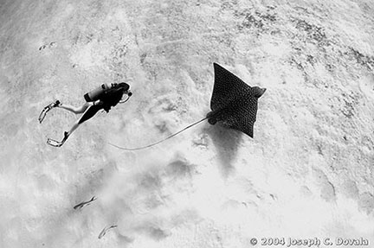

VOLUNTEER OPPORTUNITIES
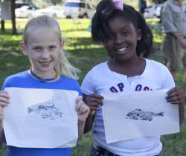
Mote Teach-A-Kid-Fishing Clinic (Saturday, November 7)

Kids Fishing Clinic-
Date/Time: Saturday November 7; 9 a.m. to 12:30
Lunch: (included) Sponsored by Sarasota Sportsmens Association
Location: Mote Aquaculture Research Park, 12300 Fruitville Road, Sarasota, FL (7 miles East of I-75).
Ages: 5-16 (plus parents/guardians); Limit 120 children
Cost: $10.00 per child
We will have the following educational stations:
1) (a) Spin casting, (b) Fly casting;
2) (a) Bait and Tackle, (b) Ethical Angling
3) (a) Gyotaku Fish Printing, (b) Kayak Demonstration
4) Fly Tying
5) Pond Fishing
6) Tours of MAP
The stations will be 30 minutes with # 1-3 split 15 minutes each.
Event Jobs:
- Registration Check -In and End of Event check-out (provide rod and reel, bait and tackle box, certificate of accomplishment, and a reusable bag of educational and fun items. We just received sponsorship this weekend for t-shirts so we can provide one to each child.
-Professional guides, anglers, and those interested to help at each station.
-Group leaders to be with each group through each station to move people in a timely manner.
-Set-up the day prior to event Friday November 6.
Please also pass the word to let families know. The sign up for children should be online by next Monday.
William R. Mote Memorial Snook Shindig 2015
honoring Captain Scotty Moore

Date: November 13-14, 2015
Location: Mote Marine Lab on City Island Park
Captains Meeting: Friday November 13, 6:00
Awards Ceremony: Saturday November 14, 5:30-9:00
Fishing Location: Sarasota Bay from Cortez to Venice.
Background:Special catch, sample and release tournament to help document contributions to the fishery of our hatchery reared snook tagged and released into Sarasota Bay. Stocked snook, tagged with coded wire tags before release into Sarasota Bay, are the focus of pilot studies to identify stock enhancement potential and the best release strategies. Snook caught during the tournament are checked by Mote researchers, who recover tag data and use the information to adjust release protocols. Our past research tournament results documented that the stocked hatchery-reared snook are contributing to the fishery in Sarasota Bay and changes in snook release strategies based on the results of these pilot studies have improved survival of our stocked snook by as much as 200%. The Snook Shindig provides outreach to help the community learn more about Mote fisheries research and fish conservation, and to gather additional evidence about hatchery snook contribution rates in the fishery and about snook population size and movements in Sarasota Bay. The results are published in scientific journals. Visit the Science Consortium for Ocean Replenishment for current publications on Motes snook stock enhancement research in Sarasota Bay. (http://www.StockEnhancement.org).

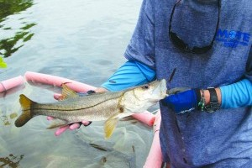
PLEASE CONTACT CAROLE NEIDIG AT
cneidig@mote.org / 941-704-7663.

Volunteers needed for 2015 Siesta Key Crystal Classic (Nov. 13-17)
Keyless, the winning sand sculpture in the 2014 Siesta Key Crystal Classic. Credit: Studio F productions.
Mote Marine Laboratory is looking for volunteers to help out during the 2015 Siesta Key Crystal Classic Master Sandsculpting Competition. The Crystal Classic benefits sea turtle research, rehabilitation and conservation programs at Mote.
The Crystal Classic takes place Friday, Nov. 13 to Tuesday, Nov. 17, 2015.
- To sign up to volunteer, please fill out an online form at www.mote.org/skcc, which includes volunteer times, days and job duties.
Volunteers for this event may be standing for long periods of time in hot sun or rain and may be walking on sandy, uneven surfaces. Please take this into consideration when choosing a volunteer position. Each volunteer must fill out their own application. One application cannot be used for two or more volunteers.
Please note: Volunteers must be at least 15 years old. No exceptions will be made.
Volunteers ages 15-18 should NOT use the online form to sign up. Instead, those ages 15-18 should contact the Director of Volunteer Resources, Robert Rogers directly at volcoordinator@mote.org or (941) 388-4441, ext. 438.
Weather: This event will take place rain or shine. All volunteers are required to report for their assigned shift regardless of weather conditions.
Dress Code: Volunteers should dress for the weather, rain or shine. Event volunteer T-shirts and wristbands must be worn and visible at all times during each shift. Tennis shoes are recommended for positions that are not located on the sand. Sunscreen is recommended for all positions.
Volunteer "Perks": Volunteers will receive a T-shirt and a special wristband, which is required to wear while volunteering. The T-shirt and wristband allows free admission for the entire duration of the event, Nov. 13-17, 2015.
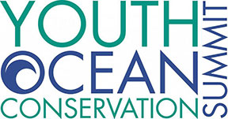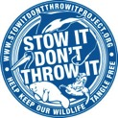
November 14 2015 • Mote Marine Laboratory • Sarasota,FL
Empowering the next generation of ocean conservationists!
Around the world, our ocean and its inhabitants face many challenges. As human impacts continuously threaten the health of our marine ecosystems, both locally and globally, it is imperative that we involve youth in a campaign to solve these problems.
The Youth Ocean Conservation Summit was created to provide youth participants of all ages (upper elementary-college) the opportunity to learn from marine scientists and conservationists about the current threats facing marine ecosystems, both locally and globally. This annual event also teaches participants about the ways other youth are currently working to protect marine ecosystems, and then allows them to work with their peers to develop action plans for their own ocean conservation projects. Workshops offered at the summit allow participants to gain the skills necessary to successfully implement conservation projects, teach participants about career opportunities in marine conservation, and expose them to opportunities they can take part in to help protect our planet's oceans and their inhabitants.

The 5th anniversary Youth Ocean Conservation Summit will be held on Saturday, November 14, 2015, at Mote Marine Laboratory in Sarasota, FL! Use the links below to register for the 2015 Youth Ocean Conservation Summit and learn more about this year's event. Registration deadline is October 15, 2015.
2015 Community Ocean Conservation Film Festival - Friday, November 13
Mote Marine Laboratory WAVE Center
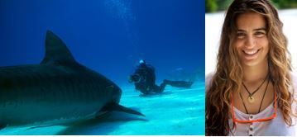
Join special guest, renowned marine conservation advocate Wendy Benchley, young ocean conservation leaders, and members of your community to celebrate the 5th anniversary of the Youth Ocean Conservation Summit program at the 2015 Community Ocean Conservation Film Festival. This special evening will feature a screening of the award-winning film Shark Girl. Shark Girl shares the inspiring story of twenty-one year old Madison Stewart who has made it her life mission to protect sharks and their ocean home. The film goes inside Madison’s underwater world, following her journey from Australia to Mexico, Palau and the Bahamas, where her extraordinary relationship with these wild animals unfolds. Madison reveals how sharks are vital to the health of our oceans. If they are endangered, so is the entire underwater ecosystem. Her journey is a powerful wake-up call and a moving record of one determined young woman devoted to protect the animal and underwater ecosystem she loves so much.
Come be inspired by the work of young conservation leaders through a showcase of student driven ocean conservation projects and films and meet young people making a difference to protect our blue planet!
The event will also feature a silent auction/raffle fundraiser with marine themed artwork and other items. Proceeds will support the Youth Ocean Conservation Summit program. Admission to this event is free. Please check out http://www.stowitdontthrowitproject.org for more info.

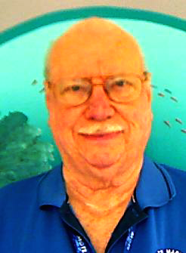

Dave Bowman retires after more than 35 years of service to Mote Marine Laboratory & Aquarium

16,000 hours — that’s 667 days or 21 months. That’s how much time Dave Bowman has spent volunteering at Mote Marine Aquarium.
Now, Mote’s longest-running volunteer is saying goodbye, as he prepares to move to Alachua.
Bowman began volunteering at Mote in October 1980, when the aquarium first opened to the public. He had recently moved down to the Sarasota area to take care of his parents and decided he needed to find a hobby in his free time.
“I went to the volunteer center for the city of Sarasota,” Bowman said. “The woman at the desk said that a new aquarium was opening and asked if I’d be interested in that. The very simple answer I had was ‘You’re damn right I would be."
Bowman served as the Saturday day chair and also as a guide at the mammal and sea turtle exhibits. He has also trained hundreds of volunteers.
In his 35 years of volunteer work at the aquarium, Bowman has seen Mote grow and evolve to become one of the best aquariums in the U.S., but its basic message of education has remained the same.
“It’s become a state institution, but it’s still the same Mote,” Bowman said. “The public education role of Mote dates all the way back to 1955. Even when we were in just one big room, we would have aquarium junkies at the exit say something along the lines of we’re a lot smaller than other aquariums, but they enjoyed it here so much more because they’ve learned. They experienced the joy of learning, not just looking at pretty fishes.”
Bowman now works the Saturday morning volunteer shift alongside other volunteers, most of whom he’s trained.
Although Bowman will no longer be a regular volunteer at the aquarium, he doesn’t plan to disappear from Mote forever.
“I plan on going to some night functions and the volunteer awards in April,” Bowman said. “There’s a 35-year pin with my name on it, and I want that. I don’t think anyone else will manage to get 35 years as a volunteer. It’s just been a very, very soul-satisfying experience. I’m going to miss the whole thing.”
Although Bowman is leaving, his legacy at Mote will remain.

GALLERY

Ocean trash photo collages by Mandy Barker

‘Soup’ is a description that is given to the plastic debris that is suspended in the sea. It is a title which makes particular reference to the mass accumulation of refuse that exists in the world’s oceans. In researching this, UK photographer Mandy Barker developed a series of images entitled ‘soup’ which depicts these plastics and discarded items salvaged from beaches around the world.
For each still, individual pieces of plastic are photographed on a black background as well as in combination with other articles of a similar size. Barker then overlays these images with one another, illustrating the smallest up to the largest items of trash, creating a feeling of depth and suspension in the final visual. The sequence of the photographs reveal a narrative referencing the often fatal results of marine animal’s exposure to ‘soup’.
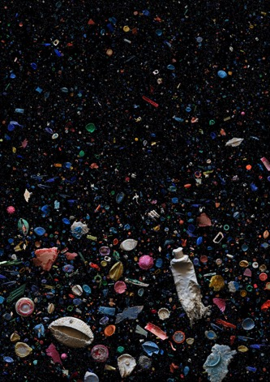
‘soup: refused’
ingredients: plastic oceanic debris affected by the chewing and attempted ingestion by animals
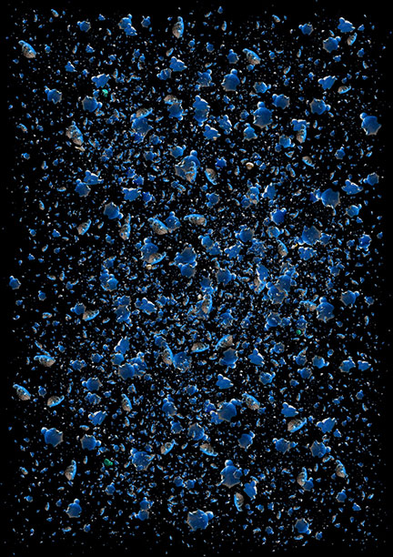
‘soup: turtle’
ingredients: plastic turtles that have circled and existed in the north pacific gyre for 16 years
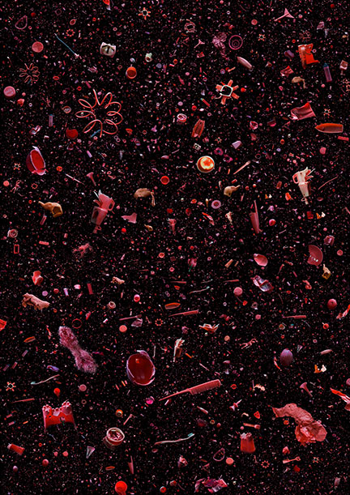
‘soup: tomato’
ingredients: red plastic debris
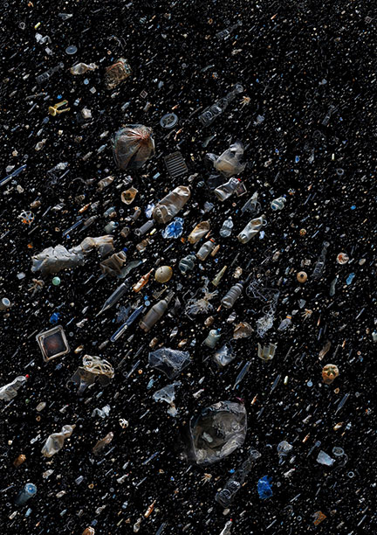
‘soup: translucent’
ingredients: translucent plastic debris
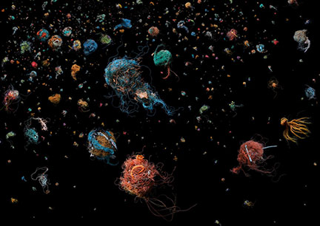
‘soup: bird’s nest’
ingredients: discarded fishing line that have formed nest-like balls due to tidal and oceanic movement with other collected debris
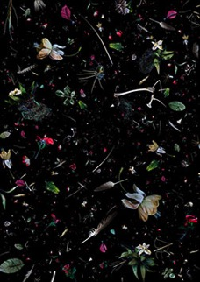
‘soup: ruinous remembrance’
ingredients; plastic flowers, leaves, stems and fishing line with bones, skulls, feathers and fish
‘soup: 500+’
ingredients: representing more than 500 pieces of plastic debris found in the digestive tract of a dead albatross chick in the north pacific gyre

Our THANKSGIVING gift to the environment

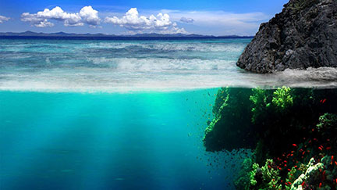
It seems like more and more supermarkets have discontinued plastic bags, switched to paper-only shopping bags, and have set up discount incentives for customers to bring their own reusable bag. That's because we're finally discovering the inconvenient truth about plastic bags: They're rarely recycled. They're made from petroleum oil. And they're an enormous harm to our environment.
If you've made the switch to reusable grocery bags, then applaud yourself for being environmentally aware. But if you're still using plastic bags, read the facts below and consider making the switch. Our world deserves to be treated better. If you'd like to recycle all your old plastic bags, find a recycling center here.
- Plastic bags take anywhere from 15 to 1000 years to decompose.
- Only 1 percent of plastic bags are recycled in the United States. The rest end up in landfills, the ocean, or some other place in the environment. There's actually a giant garbage heap made mostly of plastic floating in the ocean that's twice the size of the United States.
- It's estimated that 1 million birds and thousands of turtles and other sea animals die each year after ingesting discarded plastic bags.
- More than 10 percent of washed-up debris polluting the U.S. coastline is made up of plastic bags.
- It takes 12 million barrels of oil to produce the estimated 100 billion plastic bags Americans use each year.
- The petroleum used to produce 14 plastic bags can drive a car one mile.

OPEN TO ALL VOLUNTEERS

FALL 2015 BASIC MARINE SCIENCE COURSE

WHAT: An introductory course with emphasis on the local marine environment, Mote Research Programs, and the Aquarium. This course is for registered Mote volunteers only. This course is a training requirement for all Aquarium guides. The course is highly recommended for all other Mote volunteers. The Volunteer Manual will be used at MOST sessions and the assigned pages should be read before each lesson. A copy may be purchased for $25 (NOT A REQUIREMENT TO PURCHASE MANUAL).
WHEN: The classes will be held from Oct. 12 – December 2 from 9:00 a.m. until approximately 11:30 a.m., unless otherwise noted.
WHERE: WAVE Center (formerly Sea Cinema), unless otherwise noted.
QUESTIONS: Contact Volunteer Office at 941-388-4441, ext. 438 or ext. 852 or volcoordinator@mote.org

MONDAY, OCT. 12- ORIENTATION & CAMPUS TOUR
Bob Cameron, Volunteer Board President & Volunteer

WEDNESDAY, OCT. 14– PHYTOPLANKTON ECOLOGY
Dr. Vincent Lovko, Program Manager of the Phytoplankton Ecology Program

WEDNESDAY, OCT. 19 – MARINE & FRESH WATER AQUACULTURE RESEARCH
Dr. Kevan Main, Mote Senior Scientist and Marine & Freshwater Aquaculture Research Program Manager

WEDNESDAY, OCT. 21 – HOW HEALTHY ARE THE NATIONS WATERS?
Dr. Michael Barbour, Mote Marine Laboratory Adjunct Scientist

MONDAY, OCT. 26 - MANATEE RESEARCH/ MARINE CONSERVATION (273-294)
Dr. John Reynolds, Manatee Research Program Manager and Director of the International Consortium for Marine Conservation

WEDNESDAY, OCT. 28 – FISH HEALTH AND CARE & SHARK FEED
Evan Barniskis, Assistant Vice President for Aquarium & Biologist Staff

MONDAY, NOV. 2 - DOLPHIN, WHALE AND SEA TURTLE HOSPITALS/STRANDING INVESTIGATIONS
Lynne Byrd, Rehabilitation and Medical Care Coordinator, & Gretchen Lovewell, Program Manager & Rebeccah Hazelkorn, Staff Biologist - Stranding Investigations

WEDNESDAY, NOV. 4 – WILD DOLPHIN RESEARCH (294-306)
Dr. Randy Wells, Dolphin Research Program Manager

MONDAY, NOV. 9 – CORAL REEF ECOLOGY & MICROBIOLOGY
Erinn Muller, Mote Staff Scientist

WEDNESDAY, NOV. 11 – INTERPRETATION TECHNIQUES
Dana Henderson, School Programs Coordinator

MONDAY, NOV. 16 - BONY FISHES (213-272)
Mandy Wrobel, Public Programs Coordinator

WEDNESDAY, NOV. 18 - SEA TURTLE RESEARCH (273-285)
Kristen Mazzarella, Sea Turtle Research and Conservation Program Manager

MONDAY, NOV. 23- ARTHROPODS (131-158) & MOLLUSKS (89-124)
Kasey Gaylord-Opalewski, Sea Trek Coordinator // Educator Jason Robertshaw, Digital Learning Developer

WEDNESDAY, NOV. 25–MARINE HABITATS (41-62): THE GOOD, THE BAD & THE UGLY
Tommy Vaughan-Birch, Volunteer and Master Naturalist

MONDAY, NOV. 30 - THE AQUARIUM'S MANATEE RESIDENTS & RESEARCH (308-313)
Kat Boerner, Supervisor of Manatee Research//Laura Denum, Supervisor of Manatee Care

WEDNESDAY, DEC. 2 – ELASMOBRANCH REPRODUCTION AND BIOLOGY (177- 212) Dwight Davis, Volunteer & Dr. Carl Luer, Senior Scientist, Biomedical Research Program

