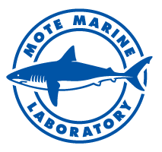

Mote shark scientist returns to Sarasota

after successful expedition on M/V OCEARCH

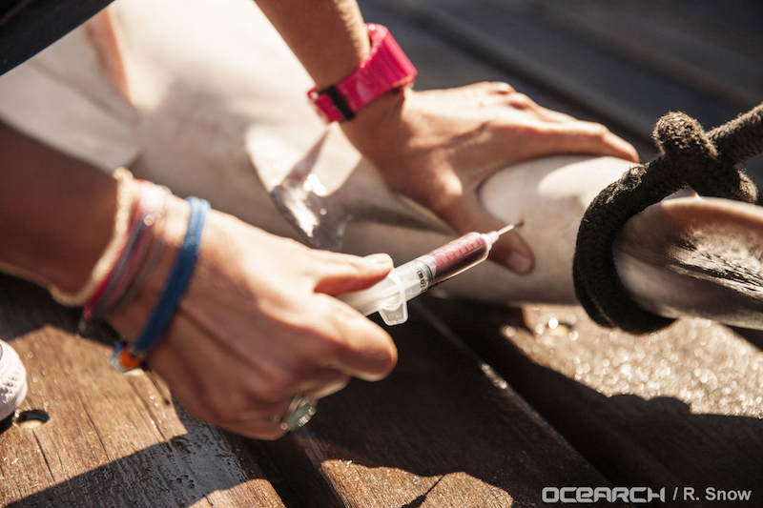

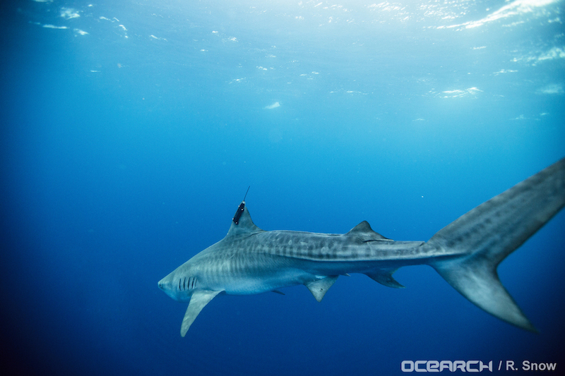

Top: Dr. Heather Marshall, Mote Postdoctoral Research Fellow, collects a blood sample from a pregnant 8-foot sandbar shark, which will be used for projects by multiple researchers on board the M/V OCEARCH, including Dr. Marshall's own research on stress in caught-and-released sharks.

Bottom: A 10-foot tiger shark named Finley swims away after being successfully tagged during an expedition in the Gulf of Mexico led by OCEARCH, with scientific leaders from Texas A & M University and a Mote Marine Lab scientist participating to collect and study shark blood samples. Finley was the last shark to be tagged on the expedition and can now be tracked on OCEARCH.org.

Credit both photos: OCEARCH/R. Snow.

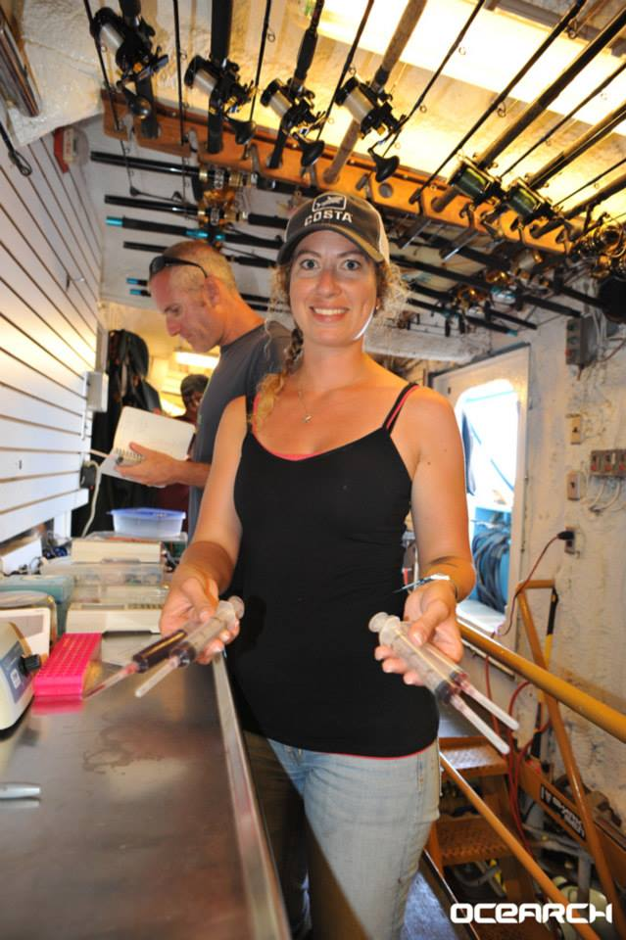

Mote Postdoctoral Research Fellow Dr. Heather Marshall just returned home to Sarasota from a two-week shark-research expedition aboard the internationally known M/V OCEARCH in the Gulf of Mexico. Marshall collected shark blood samples in this team effort to gather previously unattainable data on these important top predators.
The multi-partner expedition — led by OCEARCH with scientific leaders from Texas A&M University — departed Nov. 4 from Corpus Christi, Texas, and completed its voyage on Nov. 13 in Morgan City, La.
Since Marshall’s last update, which was posted Nov. 10 and detailed the deployment of various scientific tags on four sharks, participants caught three more sharks, including a pregnant 8-foot sandbar shark, a 6.5-foot female sandbar shark and a 10-foot tiger shark named Finley. The tiger shark was fitted with a SPOT tag, a type of satellite tag that tracks the shark’s location and sends data back to scientists when the shark’s dorsal fin breaks the water’s surface.
- The public can track four tagged sharks from the expedition at www.ocearch.org. Look for “Joseph” the 10-foot 6-inche tiger shark, “Buddy” the 7-foot, 10-inch hammerhead, “Reveille” the 8-foot scalloped hammerhead and “Finley” the 10-foot tiger shark.
Joseph, Buddy and Reveille were tagged Nov. 5 and fitted with a satellite transmitter tag that tracks its location and provides real-time updates to scientists when the shark’s fin surfaces.
Since Nov. 5, Joseph has traveled 501 miles and has pinged over 50 times, Buddy has traveled 136 miles and has pinged over 10 times and Reveille has traveled 214 miles and pinged five times.
As of Nov. 10, Finley, the last sharked tagged during the expedition, has traveled 85 miles and has pinged 10 times.
Marshall collected blood samples from Joseph the tiger shark, a 6-foot, 9-inch bull shark and an 8-foot scalloped hammerhead on Nov. 5, and then she collected samples from both of the sandbar sharks and Finley the tiger shark on Nov. 10. These blood samples are used for projects by multiple researchers on board, including Marshall’s own research on stress in caught-and-released sharks.
After anglers catch and release a shark, it is relatively unknown how the animal is affected, how long it takes to recover or if it will survive after release and how survival rates vary with different circumstances and species. This is vital information to assess shark’s vulnerability to being overfished and/or becoming accidental bycatch and maintaining healthy shark populations while preserving the top predators that help keep ecosystems in balance.

Overall, the expedition aimed to tag, sample and release hammerhead, tiger, mako sharks and other keystone species of the Gulf of Mexico. With the results coming in from tagged sharks, along with analyses of blood and other samples, participants hope to better understand how the sharks travel in relation to Gulf habitats and structures, including natural and artificial reefs and oil/gas platforms; how shark habitats connect among the U.S., Mexico and Cuba — important information for international conservation efforts; and what physiology and health traits the sharks show, especially related to stress, body condition at release and capacity to reproduce.
Read Marshall’s daily log below for a first-hand account of her research adventures aboard the M/V OCEARCH on Nov. 10.

Mote scientist Dr. Heather Marshall’s daily log of shark research aboard M/V OCEARCH, November 2015
Tuesday, Nov. 10, 2015
Today all on board were up around sunrise and I grabbed some coffee around 6:15 a.m. Today is Fernanda’s birthday! In the past we have had lucky shark days on birthdays (we tagged Betsy the white shark on my 30th), so we were hoping for the birthday momentum to continue. We knew the weather window was only going to give us this day for fishing, so we all wanted to give full effort to get some sharks on the cradle of the M/V OCEARCH, which lifts sharks out of the water temporarily for tagging and collecting samples

After a quick egg breakfast, Brandon, scientist Hannah Hart from UNF, cameraman Dan and I, among others, got a nice chum slick going off the M/V OCEARCH stern. We had out two sets of floating buoys with attached baited hooks, with a line attached to two rod & reels so we could bring in the gear and check the baits without having to use the safeboat. We got some music playing on the stern as well, so we all were feeling quite hopeful.
The Contender was out working hard, and we knew the Harte Yellowfin research boat would be joining us, too. Around 11 a.m., we saw our white indicator buoy get suddenly jerked below the waterline on our deepset gear (which we had just re-baited and deployed), indicating a fish had attempted to take the baited hook it was attached to.
We held our breaths and looked for more indication that a shark was on the line, which we got when the second, larger, orange buoy on the gear got hauled under as well. We all let out a celebratory yell, and let the Contender know that we thought we had a shark on the line. Just in time, the Yellowfin arrived and we cut the line to the rod & reel, and they took the buoy gear and checked the fish, which turned out to be a sandbar shark! The Contender came over and took the fish as we prepared to do our work on the cradle, since it was a calm enough day to actually use it! The science team made sure we had everything ready, reviewed our plan for executing the work, and eventually all was in place and we watched the Contender walk the shark toward the boat.
Captain Brett jumped in the water, and the sandbar shark was brought up. She was a beautiful 8-foot sandbar shark, and we quickly got to work to minimize stress on the animal. I got a blood sample, and Hannah did an ultrasound. We later found out that her images revealed this female was in the early stages of pregnancy! The blood samples we took will help Dr. Jim Gelschleiter’s lab correlate pregnancy hormones with pregnancy! Matt deployed an external acoustic tag on her, and we were able to get all the other science work done as well (measurements, fin clip, parasite collection, second blood sample, etc.).
This was the first time our whole team worked together on the cradle during this expedition, and it was great and felt productive to get all our work done in one shot, on the cradle. She swam off strong after release, and I got to work processing all the blood samples.

Soon after, we got lunch, but then we heard the team had another sandbar shark, a 6.5-foot female! We worked her up on the cradle as well and I took a blood sample. Spirits were quite high on deck. There was a palpable change in energy once we were all working together to do the jobs we had all come here to do.
Fernanda was ecstatic, because she was getting her birthday sharks, and after we released the second sandbar, she predicted a third shark, and that it would be a tiger. Sure enough, about an hour later, we got word that the team had hooked up with a tiger shark! Again, everything went great on the cradle as we worked up the 10-foot tiger shark and I collected a sample. This shark was SPOT-tagged and named Finley. The SPOT tag is a type of satellite tag that tracks the shark’s location and sends data back to scientists when the shark’s dorsal fin breaks the water’s surface. We continued fishing until sunset, and Finley was our last shark , but what a wonderful shark to end on. What a great last day of the expedition!
After sunset, we had birthday dinner and celebration for Fernanda! Luis made a delicious German chocolate cake with coconut frosting.Then the crew readied the boat to be moved further inshore as we knew our weather window was closing. We moved about 20 miles inshore, then anchored for the night.

UPCOMING EVENTS

VOLUNTEER HOLIDAY PARTY

The air is getting colder,
the holidays are near,
a time for celebration with
those we hold so dear!
Mote Marine Laboratory & Aquarium
cordially invites you to join us
for a festive holiday celebration!
Thursday, the seventeenth of December
six o'clock in the evening

Please RSVP to volcoordinator@mote.org

(sign-up sheets are also located in the volunteer lounges)

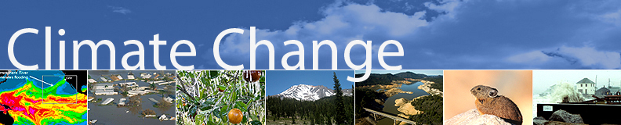

We are offering a new, special course for volunteers!
An Introduction to Interpreting Climate Change

The world’s climate is changing, and the changes will have an enormous impact on our planet’s people, animals, ecosystems, cities, and energy use. Organizations like Mote Marine Laboratory are researching impacts from climate change on marine ecosystems and animals. As an aquarium, we have a unique opportunity to discuss this global issue and associated research with our guests. This 3-hour course is an introduction into research-based techniques for incorporating climate change information, strategies for mitigation and impacts on animals/habitats to aquarium guests. We will:

- Learn how people think about climate change
- Review basic climate change science
- Introduce how to effectively weave messaging into interactions with guests
- Learn tested metaphors to explain climate change and ocean acidification
- Incorporate mitigation solutions into your conversations
- Special focus on ocean acidification

Workshops will be offered:
Saturday, December 19 9:30am - 12:30pm

The instructors:
Mote education staff, Aly Busse and Kasey Opalewski, were selected and completed a 4-month training in the competitive, NSF-funded National Network for Ocean Climate Change Interpretation (NNOCCI) program. NNOCCI’s goal is to establish a national network of professionals who are skilled in communicating climate science to the American public, to create best practices for the field and develop a community of practice around research-driven approaches to interpreting climate change in informal education settings.

Please email volcoordinator@mote.org to register for the workshop to be held in the WAVE Center. Space is limited.

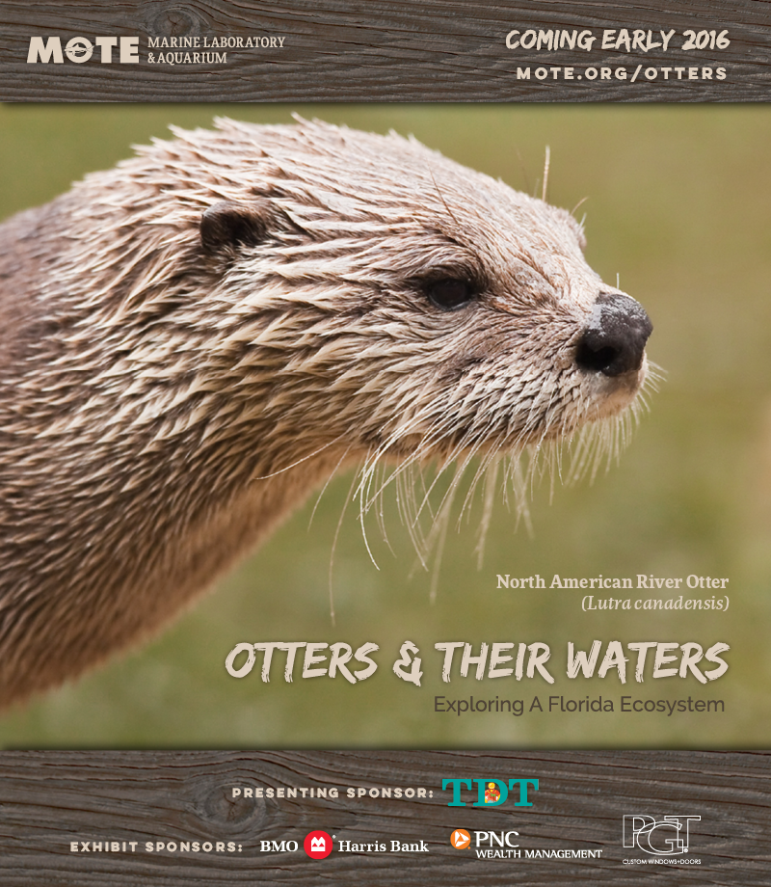

Otters coming to Mote Aquarium in Sarasota

#MoteOtters

Meet the furry faces of Florida’s watershed ecosystems in the special exhibit “Otters & Their Waters,” opening in early 2016 at Mote Aquarium.
The exhibit will feature North American river otters and provide an otter’s-eye view of their watershed homes. Watersheds — lands that drain water toward rivers, estuaries and the sea — are important to people and myriad wildlife, including river otters, their prey and many animals from land to the coastal oceans where Mote Marine Laboratory scientists carry out their research.
Visitors will see otters that were orphaned too young to survive alone and were raised by wildlife rehabilitators. Mote’s animal care specialists will work with the otters and educate guests during narrated training sessions.
“Otters & Their Waters” will be the latest of several special exhibits at Mote, following on the successes of “Penguin Island,” “Sea Lions: On the Water’s Edge,” “Survivors” and “Oh Baby! Life Cycles of the Seas.” (“Oh Baby!” remains open.)
Mote is an independent, nonprofit marine science institution dedicated to today’s research for tomorrow’s oceans, and the Lab and its public Aquarium educate hundreds of thousands of people every year, helping the public become more ocean-literate.
Soon it’ll be time for visitors to get otter-literate!
“River otters have incredibly interesting behaviors and can be very charming to observe, and we think this natural appeal will make visitors excited to learn about otter biology, ecology and the importance of their natural homes,” said Evan Barniskis, Assistant Vice President for Mote Aquarium. “As animals that fish, roam, keep dens and protect their young in our watersheds, otters will help us highlight the importance of things like healthy wetlands, the food web that interconnects many species and the ways people can take care of watersheds — which dovetails with taking care of the oceans.”

“Otters & Their Waters” will be open during normal hours, 10 a.m.-5 p.m. seven days per week, at Mote Aquarium, 1600 Ken Thompson Parkway in Sarasota, Fla. The exhibit will be located at Mote’s Ann and Alfred Goldstein Marine Mammal Research and Rehabilitation Center.

Please watch Mote’s web site and social media for upcoming announcements revealing the exhibit’s opening date and special events that will celebrate its arrival, along with names and details about the individual otters that will be featured.
This exhibit is made possible thanks to the following sponsors: Tourist Development Tax (TDT), PGT, BMO Harris Bank and PNC Wealth Management.
- To sponsor or donate to “Otters & Their Waters,” contact Erin Knievel at 941-388-4441, ext. 415 or eknievel@mote.org

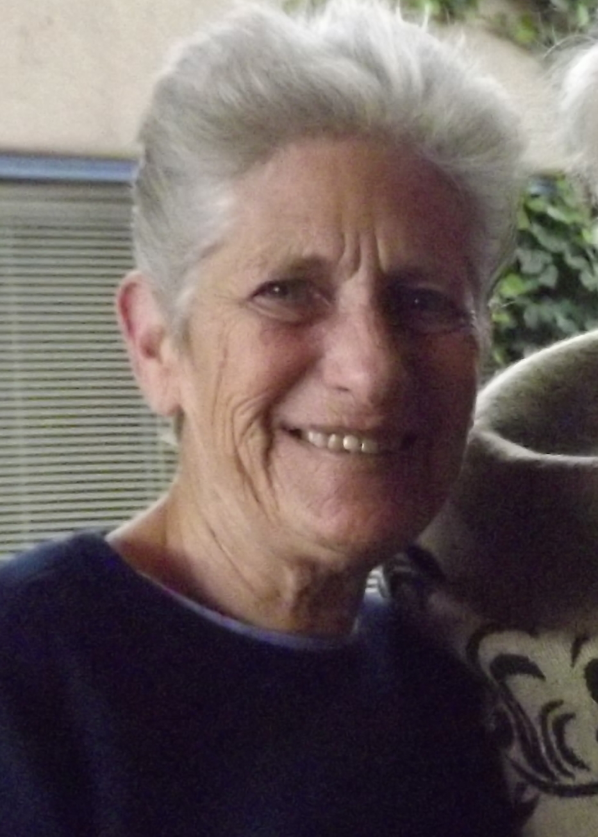

Falling for a Dolphin---and Two Manatees

By: Rolla R. Schuh

What does someone from the Bronx know about dolphins, someone who never heard of a manatee?
A few months after moving to Longboat Key, a friend of mine told me about a stranded dolphin being cared for at Mote and they needed volunteers. I said I didn’t know anything about dolphins and was told they would train me. Sure enough, I volunteered and was trained on the job by Jay Gorzelany, who was in charge of the Stranding Team, and Sarah, the volunteer coordinator.
“Freeway” was a bottlenose dolphin who had stranded up the Manatee River near I-75. He was brought to Mote and cared for in the small pool behind the Shark Tank. Since he could not swim and come up for air on his own, he was being held 24/7. Then, one day he decided to swim while I was holding him. He sunk and we picked him up. He kept trying and eventually was able to do so.
There was no marine mammal building at that time, so an enclosure was built off the dock behind the Coast Guard building leading into Sarasota Bay. The Stranding Team used the Coast Guard building as our office. Volunteers sat on the dock constantly monitoring him, recording his breaths at certain intervals and everything he did. It was wonderful to see this dolphin, who could not swim or come up for air when he first came to Mote, be able to swim, roll over and swim on his back, getting healthier by the day.
Thanks to the knowledge and care of Mote staff and volunteers they managed to treat and save him.
I will always remember the day Freeway was released- healthy and acting like a dolphin. Since I was one of the volunteers who spent many hours with him, I was asked to go along on the release which was to take place at Emerson Point. We held him in the water, and he was released from tail to head. I was holding his head and, therefore, was one of the last to let him go. He immediately swam away and then started jumping and having a grand old time. What a thrill to see him back where he belonged, happy and healthy. Everyone one was ecstatic, some laughing, some crying, but everyone amazed and grateful that he had survived.
That was it! I was hooked!!! I don’t know how many stranded dolphins, small whales and even a “beaked whale” I worked with. It was an experience that in many ways was indescribable. However, knowing we were doing something that is so important made it all worthwhile.
While I was on the dock one day during my shift, someone called out there was a manatee passing the dock. I asked, “What’s a manatee?” That was how I learned about manatees. Of course, I learned a lot more after the arrival of Hugh and Buffett, our resident manatees who were born in captivity and could not be released into the wild. They were placed in one of the tanks, and I signed up to volunteer caring for them.
During my time at Mote, I also discovered my passion for painting. Robert Wyland, an American artist best known for his 100 Whaling Walls, large outdoor murals featuring images of life-size whales, and other sea life, came to paint the outside wall of the Ann and Alfred E. Goldstein Marine Mammal Center. Even though at that time I didn’t have any idea that I would someday become an artist, I was enthralled and inspired by his process and subject matter.
It was while working with Freeway that I met Joyce Patt. We shared many shifts watching and feeding Freeway and other stranded animals. After Hugh and Buffett were brought to Mote, we also found ourselves on the same shift with them. To this day, we have remained friends and get together when our schedules permit.
I not only “fell” for a dolphin, but I also “fell” for the “boys,” as I started referring to them. Freeway was my inspiration for the first painting I did in oils. After I started taking classes in pastels, I painted “Buffett at Sunset”, which is my favorite and hangs on my living room wall.
Although I have been physically unable to volunteer for a number of years, the memories of the animals and the volunteers I worked with will always be a special time in my life that I will always treasure.

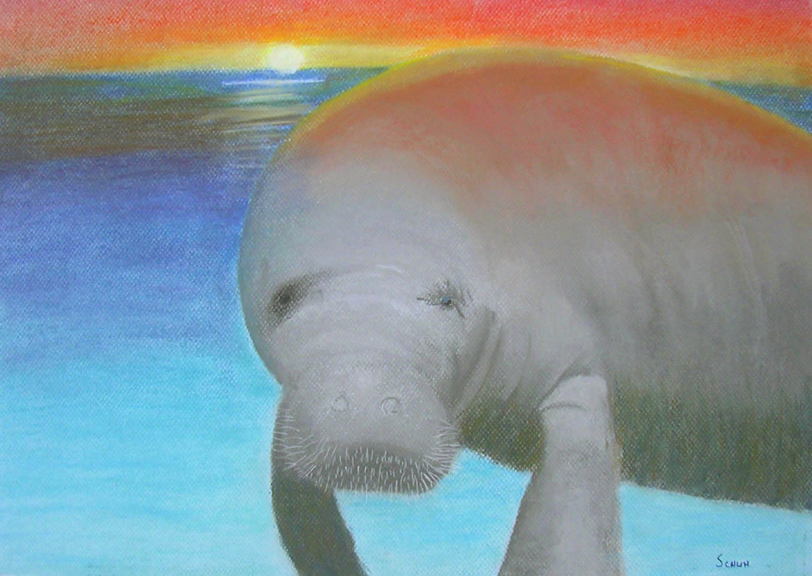
“Buffett at Sunset” by Rolla R. Schuh

GALLERY

A Gargantuan Octopus Rendered with Discarded Ballpoint Pens by Ray Cicin

Inspired in part by his graphic-designer friends disparaging comments about the lowly ballpoint pen, artist Ray Cicin took it upon himself to collect all their discarded pens and embarked on this drawing of a mammoth octopus. The piece is inspired by German naturalist Ernst Haeckel’s famous illustration of squid and octopuses, and is part of Cicin’s ongoing Deep Blue series.

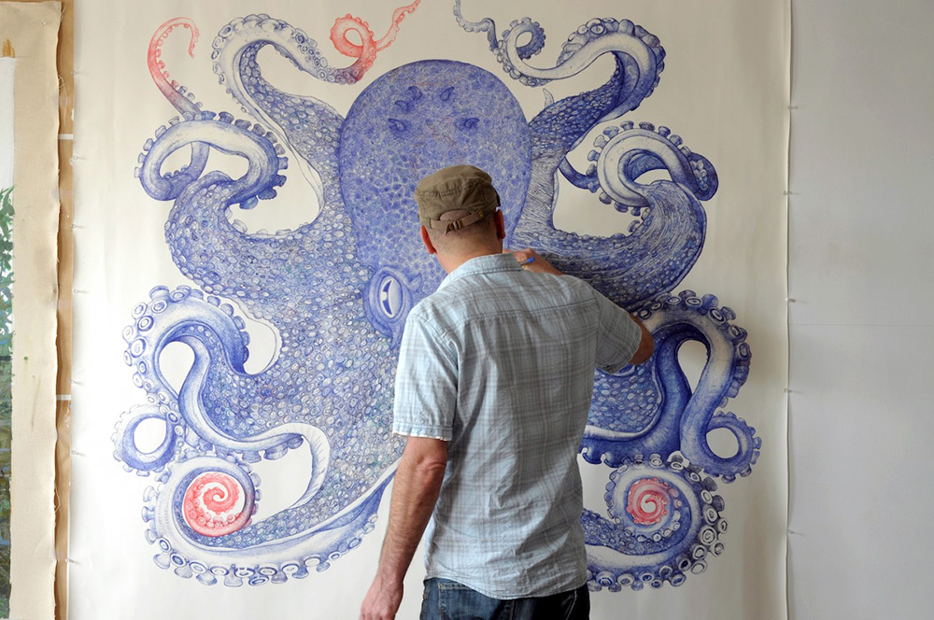

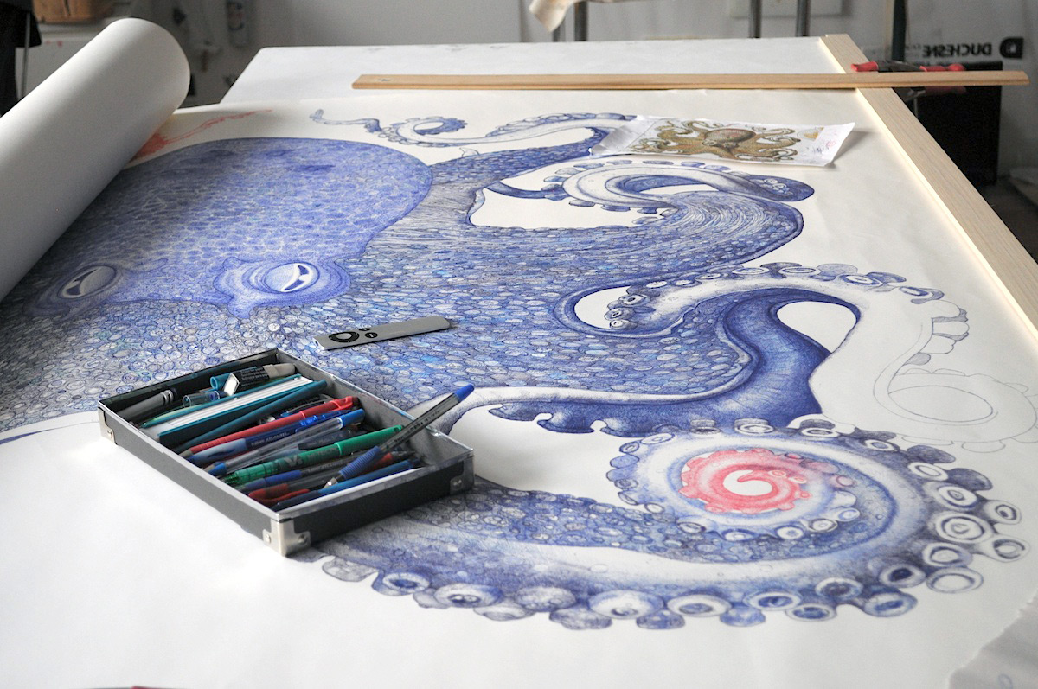
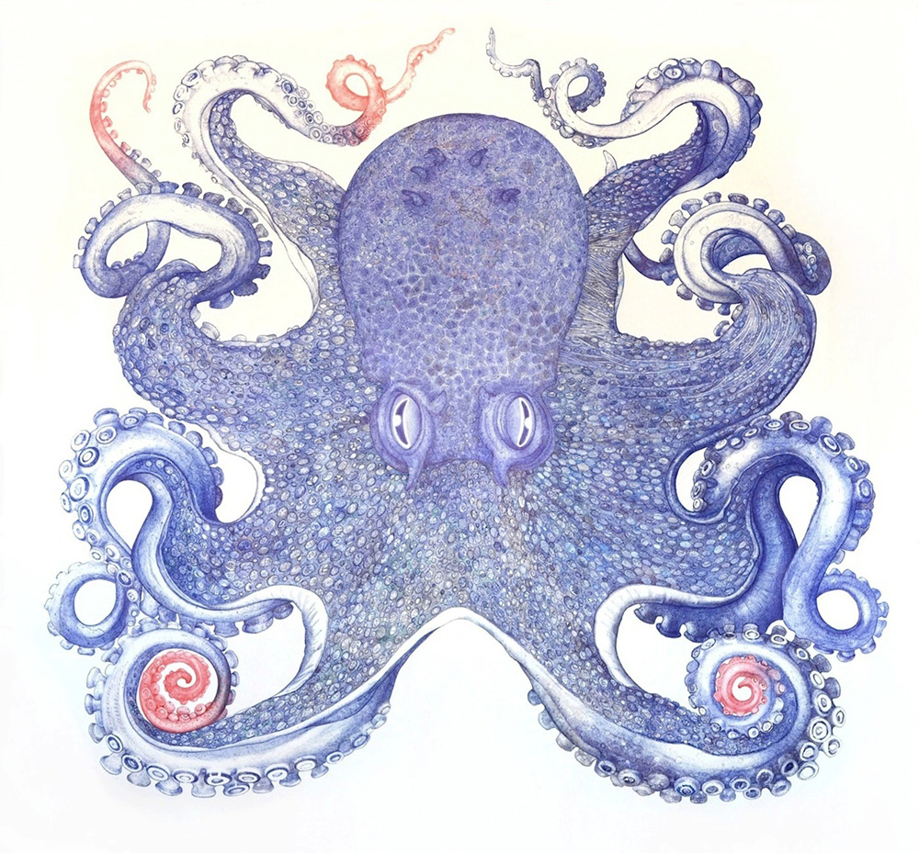
Deep Blue, Octopus. Ballpoint pen on archival Bee Rag paper, 62 x 64 inches
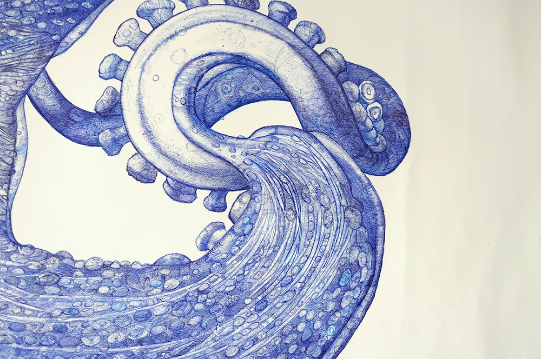
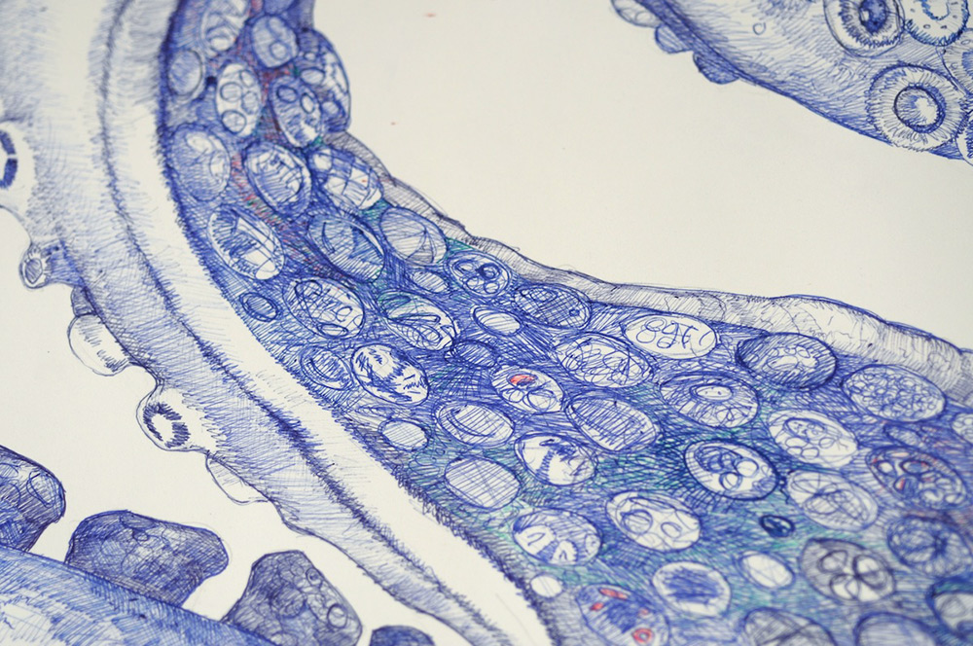

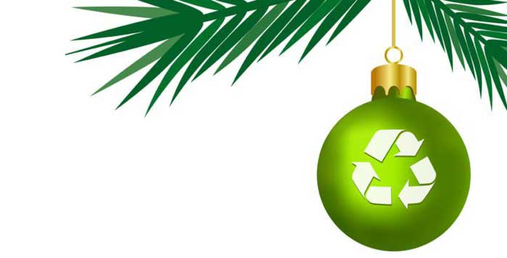

During the season of celebration we need to show extra care for the environment.

Christmas doesn't have to be a burden on the environment. With a little effort and imagination, we can reduce the environmental impact of the holiday season.

Here are some ideas to help celebrate the season while caring for the earth.

Buy Less

Some holiday gifts fill a practical need and need to be bought new. But many gifts are really gestures of thoughtfulness. You can give more while spending less.
Not all gifts have to be store-bought. You can give more while spending less by giving gifts that are personal and unique. Everyone appreciates something that shows thoughtfulness.

Homemade edibles, for example. Your time spent in the kitchen is probably no more than the time spent gift-hunting online or at the mall. And the gift of food is personal, easy on the environment, and not likely to go to waste.

Gifts of Social Service and Animal Welfare, like a membership to Mote Marine Laboratory & Aquarium, are always a great idea!

Buy Smart - think 'green'

• Look for locally made gifts
Many gifts in today's marketplace come from halfway around the world, and the impact of transportation contributes significantly to greenhouse emissions and global warming. Local craft fairs and artisan shops are a good source for gifts that come without the added costs of transportation. And gifts made locally often have a story which goes with the gift, since the artisan and the origin of the gift are known.

• Choose gifts made from recycled sources
Many individuals and small businesses have developed great products using recycled materials. Supporting these businesses helps reduce the waste stream while promoting the concept of making best use of available materials.

• Give 'battery-free' gifts
According to the EPA, about 40% of all battery sales occur during the holiday season. Discarded batteries are an environmental hazard. Even rechargeable batteries find their way into the waste stream eventually.

• 'Re-gifting' is OK
There's much discussion these days about the etiquette behind the trend to 're-gift', that is, to pass on a gift you received but do not need. What's to discuss? Re-gifting makes perfect sense. If you receive something you really don't need, look for ways you can reuse this gift by passing it on to someone who can use it. Of course, re-gifting needs to be done with care so as not to offend the original giver, but keeping a gift you don't need is wasteful.

Connect with Nature

The holidays are a time for giving, and a time for family. What a great opportunity to start a family tradition of giving back to the earth and instilling the values of sustainable living to your children, friends and community. Start an annual, earth-friendly holiday family tradition! It will also get you outdoors for a few hours to build an appetite for the big meal.

Take your binoculars, a field guide to local wildlife, a small pad or journal for each participant and walk a course through your neighborhood, beach or local park. Try to identify and count everything you see, and make a note of it in your journal. At the end of the hike, list the species seen. There's always a surprising discovery, and the activity highlights the presence and value of our local wildlife.

Take a hike! A peaceful walk through nature will be remembered and valued more than the score of the football game. Plan your walk before the holiday meal while everyone still has lots of energy. The walk will also pique appetites and provide a shared topic for conversation during mealtime.

Enjoy a nature restoration activity. Planting a small tree together symbolizes the value of nature and offsets the 'taking' of the Christmas tree. An hour spent cleaning up or enhancing a natural area also enriches the giver and acknowledges nature as the source of our well-being.
Decorate a tree for the birds. Place seed bells, suet, pine cones with peanut butter and seed trays on any tree in your yard, preferably a tree in the open where cats can be seen easily by the birds. To attract a wide variety of birds, use varied seed types such as black oil sunflower seed, wild bird mixed seed and nyger seed bells. This is a great activity for kids, and offers an important food source for birds during the winter.

Lower the impact of holiday lighting

In the past, the house with the most decorative holiday lights used to be considered the 'best'. Times have changed. The cost of electricity goes way beyond the utility bill. Electricity drains natural resources.

• Reduce the size of outdoor lighting displays
A smaller presentation of lights can still be attractive, and more appropriate in the 'season of giving'. Saving electricity is also a way of giving, since conserving resources benefits everyone.

• Use LED lights for house and tree lighting
LED (Light Emitting Diode) holiday lights use up to 95% less energy than larger, traditional holiday bulbs and last up to 100,000 hours when used indoors. LED holiday lights use .04 watts per bulb, 10 times less than mini bulbs and 100 times less than traditional holiday bulbs. Over a 30-day period, lighting 500 traditional holiday lights will cost you about $18.00 while the same number of LED lights costs only $0.19. As an added bonus, if one of the LED lights burns out the rest of the strand will stay lit.

• Outdoor Mini-lights will also save energy
A 100-light string uses only 40 watts. If you're buying a new set of lights, compare based on equal 'lighted lengths'. Some higher priced brands have 100 mini-lights for only 8 1/2 feet of length, while some 100 mini-light strings cover up to 40 feet in length. For the most efficient outdoor holiday lighting, consider the new solar LED strings now available.

• Turn tree lights and outdoor house decorative lighting at bedtime
It's simply a waste of energy to leave the holiday lights on at night after everyone's gone to sleep.
Remember, never install lights with the power on. Test lights first, then unplug to install.

Choose a live tree
Although plastic trees are reusable from year to year, real trees are the more sustainable choice. Plastic trees are made of petroleum products (PVC), and use up resources in both the manufacture and shipping. While artificial trees theoretically last forever, research shows that they are typically discarded when repeated use makes them less attractive. Discarded artificial trees are then sent to landfills, where their plastic content makes them last forever.

Live trees, on the other hand, are a renewable resource grown on tree farms, that are replanted regularly. They contribute to air quality while growing, and almost ninety percent are recycled into mulch. Live trees are usually locally grown and sold, saving both transportation costs and added air pollution. When buying a live tree, consider:
• Live potted trees can be used for years
If you buy a small tree in a large pot, you may be able to reuse the tree for 2- 3 years without having to plant or re-pot the tree.

• Re-pot the tree for longer use
If your tree becomes root-bound, you can replant it in a larger pot for several years extended use.

• Replant the tree when it becomes too large for your holiday tree
If you have the space, of course, replanting the tree outdoors is an option. Be sure to anticipate the full-grown size of the tree, and avoid planting near foundations or underground services.

• Chip and mulch the tree
Many communities now have free chipping service for trees. This is useful since the chips are used as mulch for municipal landscaping or sold at low cost to gardeners. This chipped material makes an excellent mulch for your shrub beds and garden pathways.

Homemade Cards

Store-bought cards are expensive. They also consume a huge amount of natural resources for a throw-away item. The amount of cards sold in the US during the holiday season would fill a football field 10 stories high, and requires the harvesting of nearly 300,000 trees. Homemade cards may not be as professional, but they are more personal and just as appreciated. Making the cards is also a fun activity for the family during the weeks before the holidays.
Last year's calendar is a good place to start when making homemade cards, since the images are large, colorful and printed on heavy paper similar in weight to card stock. Cut out sections of pictures and 'glue-stick' them to a folded-over piece of paper. Size the paper to fit your envelopes, or have the card and message on one side and fold over to put the address on the other side. Staple at the bottom and no envelope is needed.
Childrens art work is another good source for card pictures. Even the 'scribblings' of the wee-ones are interesting, fun and especially appropriate for the season. Parents and grandparents, aunts and uncles will probably appreciate a 'child's art' card even more than a store-bought card. Simply cut out sections of the artwork which look best, and glue-stick it to a card of the required size.
Making your own cards is easy if you have the material to work with. Try to get in the habit of saving pieces of heavy paper (good one side) to use as the backing for your glued-on pictures. "Card stock" is the ideal weight, and even small pieces are worth saving.

Alternatives to Wrapping Paper

Half of the paper America consumes each year is used to wrap and decorate consumer products.
In the US, the annual trash from gift wrap and shopping bags totals over 4 million tons. In Canada, the annual waste from gift wrap and shopping bags equals about 545,00 tons. If everyone wrapped just three gifts in reused paper or fabric gift bags, it would save enough paper to cover 45,000 hockey rinks.

• Use environmentally friendly wrapping paper
Choose wrapping paper made using fibers such as hemp, or paper using recycled content.

• Avoid buying glossy foil or metallic wrapping paper
You can do a beautiful wrapping job for your gifts without having to use metallic wrapping paper. This kind of 'paper' is difficult to recycle and it has no value for use as mulch since there are heavy metals used in the foil paper.

• Reuse gift wrap where possible
Large wrapped presents usually have large enough uncreased sections to be reused for wrapping smaller gifts. If you open large gift packages with care, the paper can be set aside for re-use for other gift-giving occasions. Fancy ribbons and bows, of course, can be stored in a box till next year when you'll appreciate having them around and not having to buy new ones.

• Use tape sparingly, or not at all
If you're going to use ribbon to finish off your wrapping, you may not need to use tape. By not using tape, more of the wrapping paper can be reclaimed, and it's easier for the recipient to save the wrapping for reuse.

• Choose alternatives to commercial gift wrap
There are many options which are cost-free, attractive solutions. Gift bags can be made using fabric scraps, or wrapping can be made using comic strips from the paper, old calendars, maps, posters and more.

Reuse/Recycle

Each year, 50 million trees are purchased in the U.S. Of those, about 30 million go to the landfill. And added to this is the carbon cost in transporting all these trees to the landfill. Much of the environmental costs associated with the holidays can be reduced by simple awareness and some pre-planning.
• Reuse or recycle gift packing materials
Bubble wrap can be stored for reuse, or recycled. Foam packing chips are not as easily recycled; if you don't want to store this material for reuse, take it to a shipping center like Mailboxes. etc, who will accept it for their own use. Cardboard boxes should be opened flat and set out for recycling; storing and reusing these boxes is even better as no additional energy is used in remanufacturing.

• Save any special gift wrap, ribbons and bows
When unwrapping large gifts, save the paper for reuse; it can often be cut down for smaller presents. Creased wrapping can be ironed flat. Ribbons and bows are easy to save and reuse.

• Recycle old electronics
New flat-screen computer monitors, laptops, cameras, cell phones and other electronic items are common holiday gifts. Older models which are being replaced are usually still in working order, however, and should not be discarded to a landfill.

• Trees can be recycled too
Live trees that have been cut are a useful material for composting. Composting requires a carbon source and trees are just right for municipal operations which use chippers to shred the material. Look for tree drop-off locations in your neighborhood. Artificial trees which are up for replacement can also be recycled. These trees are usually made from twisted metal which is accepted by most recycling centers.
Note: Never burn Christmas tree branches in your fireplace. It can cause the buildup of creosote, which is a highly flammable compound.

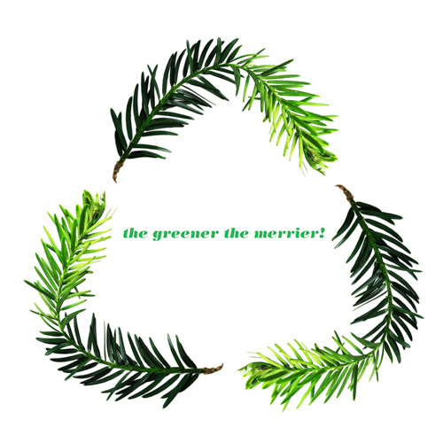

The Aquarium is currently looking for additional support for the following Guide shifts. There are sign-up sheets in the volunteer lounges or you can email volcoordinator@mote.org.

Thank you, so much, for all your help!

Jean, Ralph & Robert

Thursday, December 24 – 9:30-1:30 & 1:00-5:00
Friday, December 25 – 9:30-1:30 & 1:00-5:00
Saturday, December 26 – 9:30-1:30 & 1:00-5:00
Sunday, December 27 – 9:30-1:30 & 1:00-5:00

Thursday, December 31 – 9:30-1:30 & 1:00-5:00
Friday, January 1 – 9:30-1:30 & 1:00-5:00
Saturday, January 2 – 9:30-1:30 & 1:00-5:00
Sunday, January 3 – 9:30-1:30 & 1:00-5:00

“You are a function of what the whole universe is doing in the same way that a wave is a function of what the whole ocean is doing.”
― Alan Watts

