Recent boat strikes serve as reminders to be vigilant for marine life

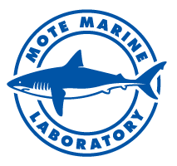
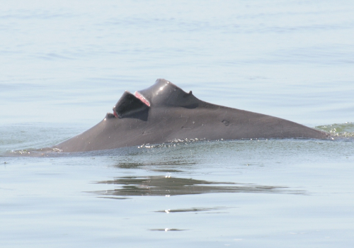

A 17-year-old male, long-term Sarasota Bay resident bottlenose dolphin was struck by a boat propeller in late June, 2015. Its fate remains unknown. Also, boat-struck sea turtles were recovered or documented on July 5 and 6 in Sarasota County. Photo credit: Sarasota Dolphin Research Program (photo taken under NMFS Permit No. 15543).
In recent weeks, several marine animals have been recovered or observed with boat strike wounds in Sarasota County waters — a reminder to remain vigilant for marine animals throughout this busy boating season.
Three loggerhead sea turtles and one Kemp's ridley sea turtle were recovered dead by Mote Marine Laboratory's Stranding Investigations Program between Sunday, July 5, and Monday, July 6. In addition, following the holiday weekend, Mote scientists documented a nesting female sea turtle with recent boat strike wounds. Mote scientists are monitoring for the turtle and noted that it has nested since being wounded — a sign that it might be able to recover successfully.
In late June, a boat propeller struck a 17-year-old male, long-term Sarasota Bay resident bottlenose dolphin. The fate of this animal cannot be determined at this time — dolphins sometimes survive less severe injuries to the dorsal fin. In general, about 5 percent of Sarasota Bay resident dolphins show evidence of having been struck by boats, and fatal collisions have been documented.
UPCOMING EVENTS
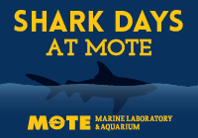

Mote Marine Laboratory and Aquarium will dive into the science behind some of the ocean’s most fascinating fishes during this year’s Shark Days at Mote: Real Sharks, Real Science – a family-friendly celebration from Monday through Saturday, Aug.10 – 15.
Monday – Wednesday: The shark-tastic fun kicks off Monday, Tuesday and Wednesday with live Google Hangouts using Mote’s SeaTrek videoconferencing technology, which will allows scientists to bring high-energy, multimedia science programming right to your computer. Each Google Hangout session is about 25 minutes and will feature real shark scientists bringing their research and fieldwork to you.
To watch the program live, you must have Internet access. To tune into SeaTrek's interactive Shark Days programs, please visit www.seatrek.tv/hangout during each program time. Each session will later be uploaded to SeaTrek’s youtube channel: www.youtube.com/seatrek.
Summer camps and other organized, education-focused groups are invited to make a Google Hangout session an interactive experience with the ability to ask questions via chat or video.
Thursday: Have questions about sharks? Adults can join Mote shark experts Dr. Nick Whitney, Dr. Heather Marshall and Jack Morris at Mote’s Sea Cinema for a special Science Café, a free, casual discussion between the experts and you! RSVP is required and details will soon be available from Mote's web site.
Friday: Children can embrace their creative side while learning about one of the ocean’s most magnificent creatures with Sharks & Crafts, a crafts event in the Aquarium’s courtyard. Sharks & Crafts is free with regular paid admission to Mote Aquarium and is free for Mote Members.
Saturday: Shark Days at Mote will wrap up with Fins and Fun, a family festival! Enjoy games and crafts in the Aquarium’s courtyard. The family festival is free with regular paid admission to Mote Aquarium and is free for Mote Members.

Introducing the newest member of our Volunteer Resources Team

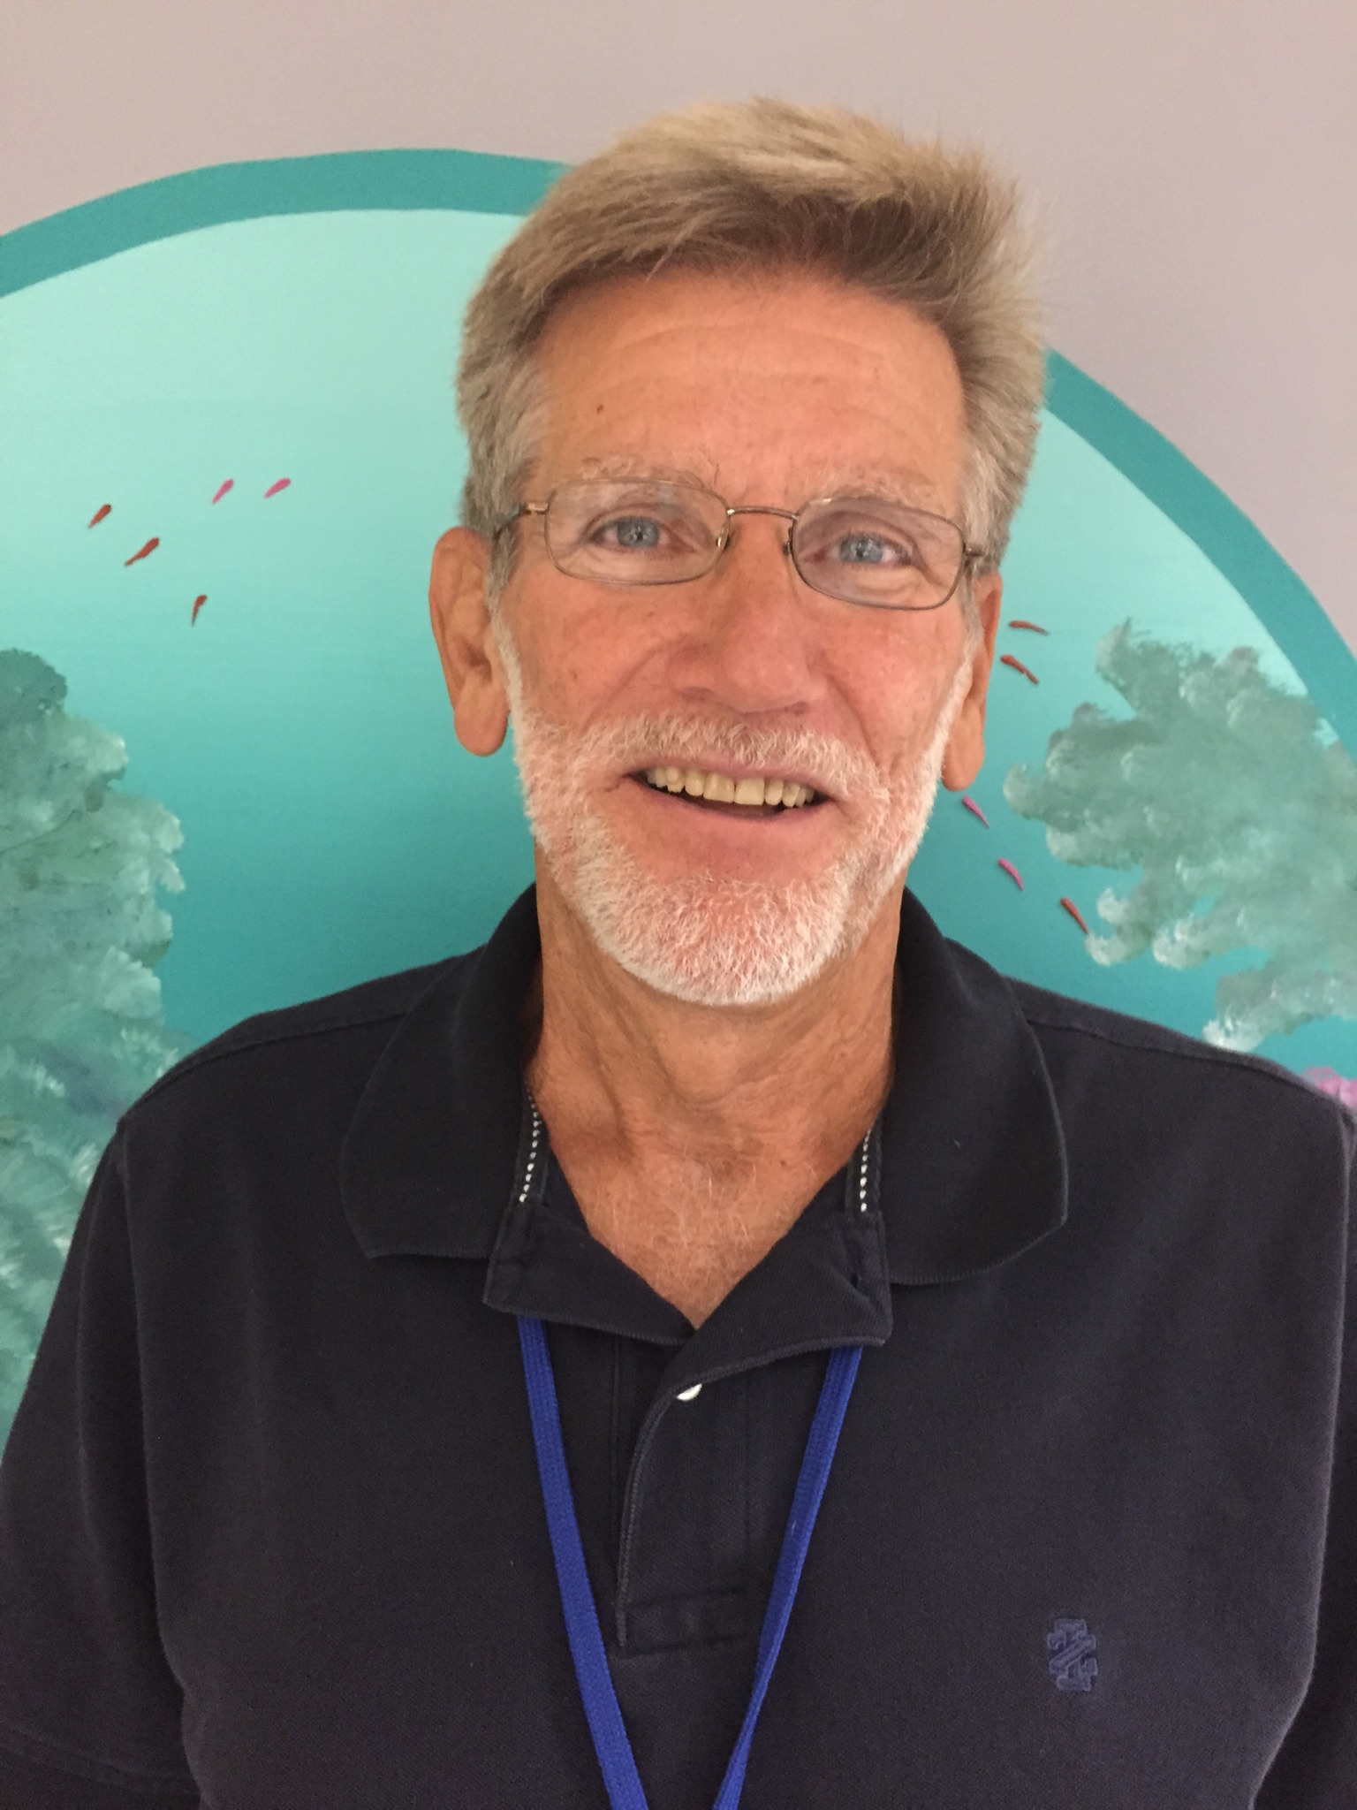

We are extremely happy to announce that Ralph Course will be joining the Mote Volunteer Resource Department staff as a Volunteer Coordinator alongside Jean Smith-Kruse and Robert Rogers.

Ralph Corse is a retired educator after having worked as a science and biology teacher for the first twenty years of his career and then as a large school district science specialist and director of curriculum and instruction during the last twenty years. Ralph earned a Bachelor of Science in Education Degree from Southeast Missouri State University and received Master of Arts and Educational Specialist Degrees in Educational Administration from the University of Missouri at Kansas City. He has a certification in Educational Leadership and teaching certifications in Science, Biology, Language Arts, and Social Studies.

During the summers while serving as a teacher, Ralph worked as a Park Ranger and Interpretive Specialist at Wappapello and Smithville Lakes in Missouri and as an Environmental Science Educator and Group Leader at Mingo Wildlife Refuge in Southeast Missouri. He also served one of the writers of Missouri’s Science Standards and during that time served on the Governor’s Environmental Education Task Force in Missouri.

Upon retiring in 2011, Ralph has volunteered as an Aquarium Guide at Mote Marine Laboratory in both the Marine Mammal and Fish and Invertebrate areas. For the past eight months, Ralph has served on the Mote Volunteer Association Board. He also volunteers on the Anna Maria Island Turtle Watch and Shorebird Monitoring Program. Ralph lives a very active life boating, bicycling, and running. He ran and even placed in Mote’s 5K Run for the Turtles the last two years. Ralph Corse lives in Holmes Beach, Florida with his wife, Denise.

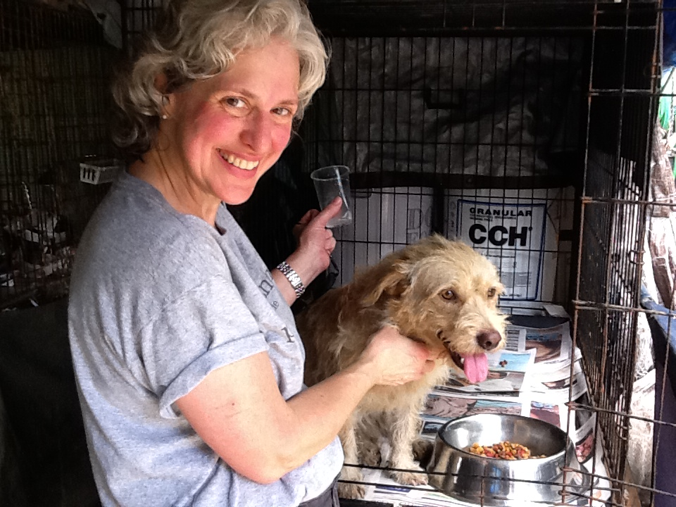
Ellen La Torre in Puerto Rico with one of the dogs she rescued (now a therapy dog in NJ!).

Ellen La Torre recently moved to Sarasota from New Jersey where she worked as the Director of Finance for the Monmouth County SPCA in Eatontown, New Jersey for over fifteen years. In 2009 Ellen co-founded the non-profit organization Project Animal Worldwide and served as its President for two years. During that period she produced and directed the award-winning documentary, Spirit of the Sato, the Journey of Puerto Rico’s Lost Dogs detailing the plight of the abandoned dogs of Puerto Rico. Ellen currently serves on the board of Puerto Rico-based non-profit All Sato Rescue.

When asked why she chose to volunteer with Mote, Ellen replied, “I visited Mote several times when visiting friends in Sarasota who were volunteering here. I was so impressed with Mote's mission, professionalism and people (volunteers and staff) that when we moved to Sarasota in March I knew I wanted to volunteer here. I've only been here a short time but look forward every week to seeing the other volunteers and, of course, sea turtles Montiego and Shelley and everyone's favorite manatees Hugh and Buffet at the Marine Mammal Center.”

GALLERY

Remarkable photographs reveal hidden charms of ordinary sand
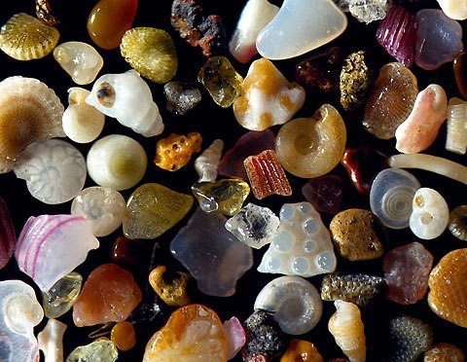
Professor Gary Greenberg/SWNS
Viewed at a magnification of over 250 times real life, tiny grains of sand are shown to be delicate, colourful structures as unique as snowflakes.
When seen well beyond the limits of human eyesight, the miniature particles are exposed as fragments of crystals, spiral fragments of shells and crumbs of volcanic rock.
Professor Gary Greenberg who has a PhD in biomedical research from University College London said: 'It is incredible to think when you are walking on the beach you are standing on these tiny treasures.
'Every time I look through my microscope I am fascinated by the complexity and individuality created by a combination of nature and the repeated tumbling of the surf on a beach.'
Prof Greenberg, who searches through thousands of tiny rocks with acupuncture needles to find and arrange the most perfect specimens, then uses a painstaking technique to create his images.
He has spent five years searching the globe for remarkable sand grains like these to photograph.
He said: 'Extreme close up photography normally gives a very shallow depth of field so I had to develop a new process to make the pictures that I wanted.
'I take dozens of pictures at different points of focus then combine them using software to produce my images.
'Although the pictures look simple each grain of sand can take hours to photograph in a way that I am happy with.
'The beach nearest my lab is Haiku, Hawaii but my pictures show sand from all round the world from Japan to Ireland.'

How sand is made
Sand is tiny fragments of rock that have been worn away over thousands of years.
Contrary to popular belief, sand is made as rocks crash and break in rivers and streams on their way to the sea, rather than the ebb and flow of the tides.
Deposits left by breaking rocks in the sea turns to silt and is much lighter so is dispersed over a much wider area out to sea, rather than on the shore line.
Some of the rock is soluble, but other bits remain and as they are slowly rubbed down over time they get smaller and smaller until they become what we know as sand.
'Every time I look through my microscope I am fascinated by the complexity and individuality created by a combination of nature and the repeated tumbling of the surf on a beach.'
Prof Greenberg, who searches through thousands of tiny rocks with acupuncture needles to find and arrange the most perfect specimens, then uses a painstaking technique to create his images.
He has spent five years searching the globe for remarkable sand grains like these to photograph.

