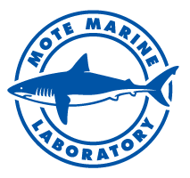

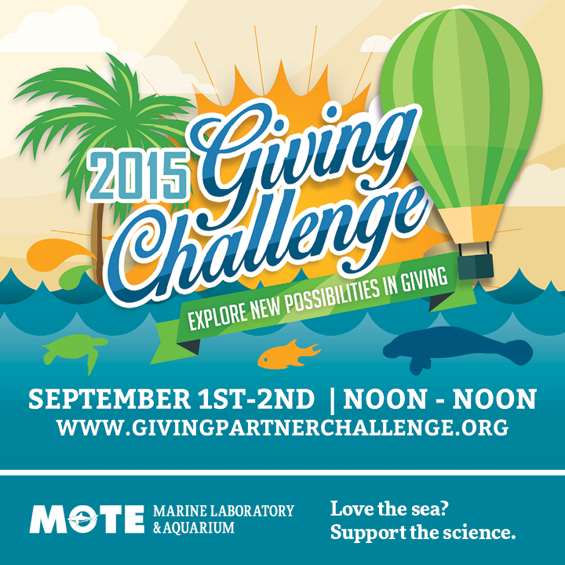

Sept. 1-2: Support Mote during annual Giving Challenge

Mote Marine Laboratory is participating in the 2015 Giving Challenge, a 24-hour online fundraising event from Sept. 1 at noon through Sept. 2 at noon, and Mote is looking to the community for support.

Instead of a telethon, the Giving Challenge is an “Internet-a-thon,” which provides a way for the community to support their local nonprofit organizations, including Mote, through online donations that are matched by area organizations.

This year’s Challenge is made possible by the Community Foundation of Sarasota County and The Patterson Foundation with support from the William G. and Marie Selby Foundation, John S. and James L. Knight Foundation, Manatee Community Foundation, and the Herald-Tribune Media Group.

The event features an online leaderboard at www.givingpartnerchallenge.org, updated every 60 seconds allowing the community to give and view the amount of donations and dollars each organization has raised in real time.

Mote has participated in the Challenge for the past three years, and has raised more than $100,000 each year. Mote is delighted to announce that thanks to two anonymous donors Mote will be able match all gifts from the Giving Challenge on a 1:1 basis up to $40,000.

Building on the established partnership between Mote and Microsoft, Mote is proud to also announce its partnership with Microsoft for the 2015 Giving Challenge. Mote and Microsoft will be promoting their partnership in the Microsoft store at the University Town Center and in the Mote Aquarium.

To support Mote in this year’s Giving Challenge, read more about the Challenge below.

How it works:

- Donations must be made online between noon on Tuesday, Sept. 1, and 11:59 a.m. Wednesday, Sept. 2, at www.givingpartnerchallenge.org
- Gifts from new donors (those who did not donate to Mote in the 2014 Giving Challenge, but may have donated to Mote in previous Giving Challenges) will qualify for a $250 match
- Mote will additionally match gifts up to $40,000 thanks to a two anonymous donors
- A debit or credit card must be used
- Donations are 100 percent tax deductible

To learn more about Mote’s campaign, visit Mote’s Giving Partner Profile.

Aquaponic fish and veggies make their dinner table debut

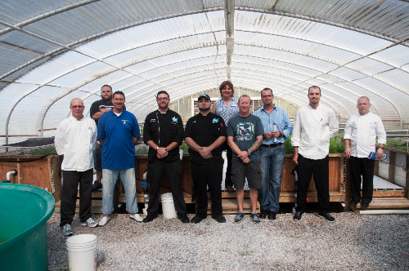

On June 15, sustainable and locally driven chefs toured Mote Aquaculture Park to learn more about Dr. Main’s sea vegetables that have advanced from farm-to-fork. From left to right: Chef Tim Pheasant (Glenridge), Chef Brian Nieman and Chef Jesus Machado (Marker 4), Chef Josh Booze and Sous Chef Peter Mosher (FINS), Chef Stephen Phelps (Indigenous), Chef Tyson Grant (Parkshore), Chef Matt Dahlkemper (LOCALE), and Chef Kenny Hunsberger (Don Cesar). Credit: Mote Marine Laboratory.

From farm-to-fork, sea vegetables and red drum, a saltwater fish species, grown at Mote Aquaculture Park (MAP) using aquaponics – raising seafood while using the wastewater to fertilize salt-loving crops – are making their way into Southwest Florida’s eco-friendly food scene.
Mote Marine Laboratory’s commercial demonstration project in marine aquaponics launched in fall 2014. The project uses eco-friendly technology developed at MAP to farm raise red drum, which is now being sold to restaurants from Sarasota to Tampa, with sea purslane and saltwort, edible sea vegetables that are now being plated in certain local restaurants and sold at the Sarasota Farmers Market.
Dr. Kevan Main, manager of the Marine and Freshwater Aquaculture Research Program at Mote, started this project with the intention of bringing its tasty results to the community and educating people about the importance of locally produced food.

“The goal of this project is to provide opportunities for local, community-based food production,” Main said. “More than 90 percent of the seafood consumed in the United States is imported. It is important that we start thinking about local, sustainable food production.”
The marine aquaponics project uses a closed-loop recirculating system that allows Mote scientists to raise saltwater fish while recycling 100 percent of the water.
The water is first used to raise the red drum, a hearty marine fish that grows well in aquaculture conditions.
Several filters remove the waste produced by the fish and allow bacteria to break down harmful ammonia into other nitrogen-rich compounds used to fertilize the roots of sea purslane and saltwort, which are planted in four raceways in an aquaponics greenhouse. As the nutrients run low, the water is passed through a filtering screen and returned to the fish.
The solid fish waste produced by the aquaponics system is then used to grow wetland plants such as mangroves and salt marsh grasses for coastal restoration projects in partnership with Aquatic Plants of Florida.
The edible plants and the red drum from the system might just end up on your dinner table.
As of July 2015, the red drum has been available to restaurants through seafood wholesalers and the sea purslane has been distributed by the same seafood wholesalers and sold at the Sarasota Farmers Market since January 2015.
“I really wanted to find out what sea vegetables we could provide as local food to local markets, because the availability of vegetables grown from fresh water is decreasing and in the future, we are going to be eating vegetables grown from the sea,” Main said. “I am very excited to be introducing this way of food production to the community.”
The community has enjoyed buying the sea vegetables at the local Sarasota Farmers Market, and chefs focused on local, sustainable foods are key to the project’s success.
In June, local chefs toured MAP to get a taste for Mote’s marine aquaponics project. Katie Sosa, Vice President of Sales at Sammy’s Seafood Inc., organized the tour in an effort to partner with Main’s vision and be a spoke in her wheel of product distribution.
“Sammy's Seafood is excited to be distributing the fish and the sea vegetables grown at Mote’s aquaculture facility and we’re happy to connect chefs who are passionate about local, sustainable food with Mote,” Sosa said.

Restaurants including Indigenous in Sarasota, Seafood Shack Marina, Bar & Grill in Cortez and Locale in St. Petersburg all use sea purslane that is grown at MAP in their restaurants on a regular basis.
Stephen Phelps, Chef and Owner of Indigenous, has incorporated the sea purslane grown at MAP into his dishes for several months.
“We have a lot of different applications for the sea purslane right now; we’ll tear off the leaves and toss them into sauté dishes or salads. We’ve also started to pickle some of it,” Phelps said.
“And the saltwort has been a big hit, too, Phelps added. “We’ve used it as a very pretty garnish on saltwater fish. We’ve also tempura battered the saltwort and fried it very quickly and that makes it look like coral on top. But we’ve also been pureeing it and emulsifying it. It adds this natural saltiness to everything we are making. So now we’re learning it is not only just this amazing vegetable, but it is also a great spice. It’s a great way to give everything sea salt flavor without using a pinch of sea salt.”
Phelps not only uses the sea vegetables for his restaurant — he has also found a place for them his personal life.
“As a product in the culinary world it has great potential, especially with the incredible health benefits it has,” Phelps said. “I’ve tried it in smoothies. I take the leaves of the vegetables, throw it in with some apple, parsley and kale, which makes for a really nutrient rich smoothie.”
Gerard Jesse, Executive Chef of Seafood Shack, also uses the sea purslane in a couple different dishes in his restaurant on a regular basis, including a vegetable summer roll and local fish sandwich. He said, “The sea purslane has great depth of flavor – you can get the salty flavor without having to add a lot of salt and it’s a good source of vitamin C. Additionally, it’s very important to us to support our local farmers and producers, something we’re committed to.”

As of July 2015, the program has raised about 350 fish and is producing about 160 quarter-pound bunches of sea purslane a month.
"Research is underway to continue improving this sustainable technology to produce sea vegetables and fish for local communities in Florida,” said Dr. Main.

Mote and The Nature Conservancy partner in new pilot internship program to inspire next generation of scientists

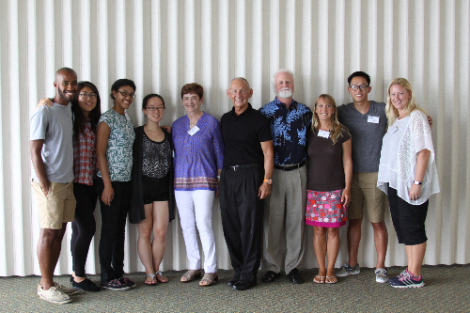

Mote celebrates new partnership with The Nature Conservancy with a reception that brought together Research Experiences for Undergraduates – LEAF Alumni interns, their Mote scientist mentors and the program's sponsors. Left to right: Lian Valera, intern; Lucinda Li, intern; Brie Colon, intern; Joan Kim, intern; Linda Monda and Keith Monda, program sponsors; Dr. Michael P. Crosby, President and CEO of Mote Marine Laboratory; Dr. Erinn Muller, Staff Scientist at Mote; Peter Chen, intern; and Dr. Andrea Larsen, Postdoctoral Scientist at Mote.

On Friday, July 24, Mote Marine Laboratory celebrated a new partnership with The Nature Conservancy, which gave five college interns a rigorous, marine research-based internship opportunity during the 2014-2015 school year.
Mote and The Nature Conservancy teamed up this year to create the pilot internship program Research Experiences for Undergraduates – LEAF Alumni.
The new pilot internship program drew upon Mote’s 11 years of experience hosting the internationally recognized internship program Research Experiences for Undergraduates (REU) and The Nature Conservancy’s high school internship program, Leaders in Environmental Action for the Future (LEAF).

The 10-week program is coordinated directly through Mote’s internship resource office and offers high school students who participated in The Nature Conservancy’s LEAF program a way to continue their internship experiences as college undergraduate students. It is designed to provide hands-on opportunities for students to conduct scientific research under the mentorship of Mote scientists.
Four student interns were selected to work with Dr. Erinn Muller, Manager of the Coral Health & Disease Research Program at Mote, from May 30 through Aug. 7, 2015.
“I feel so incredibly blessed to be here because it’s such a great program – I am learning so much,” said Joan Kim, Research Experiences for Undergraduates – LEAF Alumni intern from Tufts University. “My mentor, Dr. Erinn Muller, has been such a great resource. Before this, I was thinking of making a career out of environmental communication and relaying the importance of environmental science to a larger audience, but now I realize I want to do the science and I want to help people understand what I am doing and why it matters.”
One student was selected to work with Dr. Andrea Larsen, Mote Postdoctoral Scientist in the Marine Immunology Program, for the 10-week program.
“This program has helped me a lot and has prepared me for the future,” said Lian Valera, recent graduate of the University of Vermont. “The tests I am doing in the lab are directly associated with epidemiology, which is what I’d like to pursue as a career as I apply for my master’s degree. Not only does my mentor, Dr. Andrea Larsen, have incredible patience, but she has incredible knowledge and she has taught me and encouraged me every step of the way.”
On Friday, Research Experiences for Undergraduates – LEAF Alumni students and their mentor scientists celebrated the partnership between Mote and The Nature Conservancy, and met Linda and Keith Monda, who sponsored the program.
“Our philosophy is those that have been blessed have the obligation to give back, and I feel like we’ve been incredibly blessed, so we focus our energy on philanthropy and service,” said Keith Monda. “We particularly focus those efforts to include children, education and conservation. This opportunity to partner Mote with The Nature Conservancy is the trifecta of what we believe in. I am thrilled to be able to support this, because the students in this room are the future and we have to do everything we can to ensure that they’re successful.”
Keith Monda is a former trustee and longtime supporter of The Nature Conservancy, retired President and CEO of Coach, Inc., and a passionate philanthropist who made the pilot internship program a possibility.

“It is wonderful to gather the students, the mentors and the supporters together all in one room,” said Dr. Michael Crosby, Mote CEO and President. “Today we celebrate the three pillars that Mote was founded on 60 years ago – passion, partnerships and philanthropy. We celebrate the passion of our scientists, which is passed down to the next generation through programs like this. We celebrate this new partnership with The Nature Conservancy, which allows us to provide more undergraduate research experience focused on the next generation of leaders in environmental science and conservation. And we celebrate philanthropy, because Mote is an independent research institution that can only survive if we have philanthropic support, as the Mondas have so graciously given us.”
The experience gained through the Research Experiences for Undergraduates – LEAF Alumni program aims to enhance knowledge and experience needed for entry-level employment and graduate studies in marine science-related fields.
The program allows students to gain experience in planning and implementing scientific research under the direction of a Mote scientist, earn a stipend, hone scientific writing skills by completing a "manuscript-style" final report, attend scientific seminars presented by graduate students, Ph.D. scientists from Mote, government agencies or universities and learn about opportunities for graduate study, careers in marine science and related communication skills through student workshops.
“Opportunities like this inspire the next generation of scientists,” Crosby said. Two of our Ph.D. scientists started out right where these students are standing, as interns at Mote. They finished school, got a lot of experience and are now world-class researchers at Mote. We just can’t thank the Mondas enough for giving these kids the opportunity to be inspired by science.”

UPCOMING EVENTS
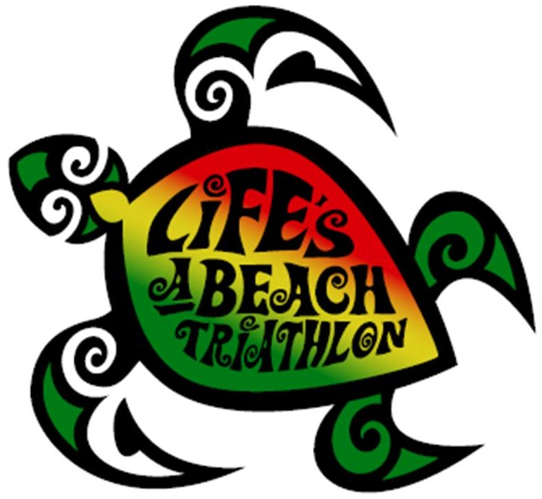

Sept. 12: Life's a Beach Triathlon
to raise funds for sea turtles

Grab your swimsuit, your most festive Hawaiian shirt and your running shoes for the fourth annual Life's a Beach Triathlon, organized by Endeavor Racing, LLC, on Sept. 12.
Triathlon participants are invited to Sarasota’s beautiful Lido Beach for swimming, biking and running.
For every full-price entry, the Life's a Beach Triathlon will donate $1 to Mote's Sea Turtle Conservation and Research Program, which has coordinated sea turtle conservation for more than 30 years along 35 miles of Sarasota County beaches.
The Life's a Beach Triathlon will take place on Lido Beach/Lido Beach Resort at 400 Ben Franklin Parkway, Sarasota, Fla.
- For registration and details including start times, cost and a list of event sponsors, visit: www.lifesabeachtriathlon.com/2015_Sarasota.php

Saturdays in September:
$6 Mote admission for Florida residents
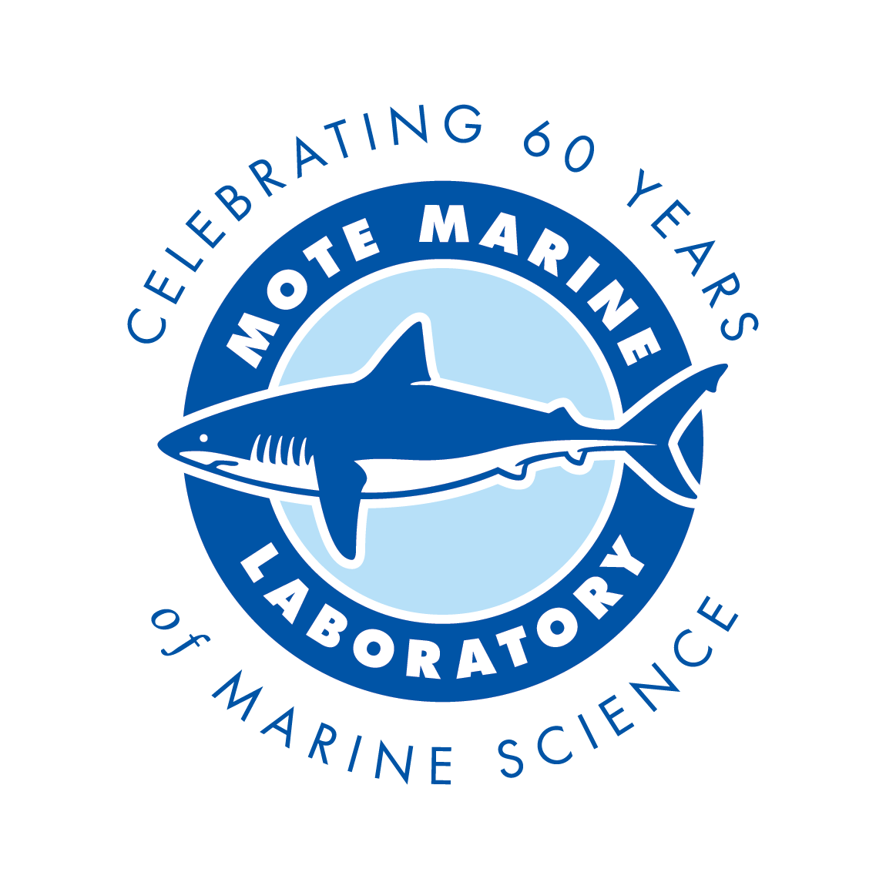

In honor of Mote Marine Lab's 60th anniversary, Florida residents are invited to discover the wonders of Mote Aquarium for just $6 every Saturday this September.
This year, Mote is celebrating 60 years of world-class marine research and education. As an independent, nonprofit Lab, Mote has succeeded through its wonderful partnerships with local communities, and we are excited to give back.
For every Saturday in the month of September, Florida residents of all ages can receive Mote Aquarium admission for $6 by providing proof of residency for at least one person in your group. The special is valid for up to four people in a party.
Mote looks forward to many more decades of groundbreaking research and to enhancing ocean literacy for even more people. Mote Aquarium is dedicated to sharing Mote research and encouraging future generations of scientists, educators and the public to explore their interest in marine science and to make more informed decisions about marine conservation.
You can also help Mote celebrate its 60th anniversary by wishing Mote a happy birthday and sending your most creative birthday wish. You can send all greetings, pictures, scanned drawings, pictures of you with Mote gear on, videos, creative artwork, etc., to info@mote.org. We will compile the most imaginative submissions into a Facebook album for everyone to see. (Let us know in the email if you do not wish for your submission to be displayed publicly).

Thank you for helping us celebrate our birthday!

September:
Support Mote by dining at Columbia

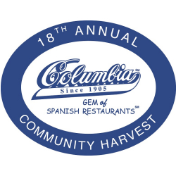

Enjoy good eats for a great cause: Support Mote Marine Laboratory by dining at Columbia Restaurant any time during September.
Choose Mote from the ballot provided by your server and Columbia will donate 5 percent of your check to Mote, one of the nonprofits in the 18th Annual Columbia Restaurant Community Harvest.
The Community Harvest benefits deserving nonprofits near Columbia Restaurants in: Sarasota; multiple Tampa locations including Ybor City; St. Augustine; Clearwater Beach; and Celebration. Since 1998, Columbia has donated over $1.6 million to nonprofits throughout Florida.
Mote is an independent, nonprofit marine science and education institution dedicated to today's research for tomorrow's oceans.
All Columbia locations are open seven days a week for lunch and dinner. In Sarasota, Columbia is located at 411 St. Armands Circle. For hours and other information, visit: www.columbiarestaurant.com
Volunteer General Meeting in Sea Cinema Thursday, October 8th 9:00-11:00 Presents: Ocean Technology with Guest Speaker Dr. Jordon Beckler

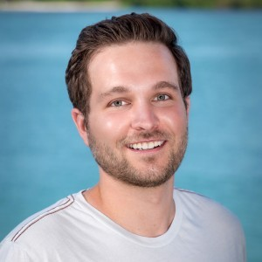

Dr. Jordon Beckler joined the Mote Ocean Technology group in February of 2015. He earned a Ph.D. in chemical oceanography with a minor in inorganic chemistry at Georgia Tech, where he researched the redox cycling of metals and sulfur using in situ electrochemical analyzers and HPLCs during his dissertation research. He has extensive field experience on oceanographic research cruises and has had the opportunity to explore hydrothermal vents and other deep-sea environments with DSV ALVIN and other ROVs. At Mote, Jordon manages the SO-COOL Harmful Algae Bloom monitoring network of optical phytoplankton detectors and coordinates deployments of Slocum gliders around the Gulf of Mexico.
He also brings some exciting new projects to the Ocean Technology program:
1) developing techniques to use in situ HPLCs to measure red tide toxins
2) evaluating the potential for iron flux from sediments to initiate red tide blooms on the West Florida Shelf. In his free time he enjoys surfing, fishing, and exploring the oceans with his home-built ROV.

We are offering a new, special course for volunteers!
An Introduction to Interpreting Climate Change

The world’s climate is changing, and the changes will have an enormous impact on our planet’s people, animals, ecosystems, cities, and energy use. Organizations like Mote Marine Laboratory are researching impacts from climate change on marine ecosystems and animals. As an aquarium, we have a unique opportunity to discuss this global issue and associated research with our guests. This 3-hour course is an introduction into research-based techniques for incorporating climate change information, strategies for mitigation and impacts on animals/habitats to aquarium guests. We will:
- Learn how people think about climate change
- Review basic climate change science
- Introduce how to effectively weave messaging into interactions with guests
- Learn tested metaphors to explain climate change and ocean acidification
- Incorporate mitigation solutions into your conversations
- Special focus on ocean acidification

Workshops will be offered:
- Wednesday, August 26, 2015 - 9 am-12 noon
OR
- Friday, September 4, 2015 - 9 am-12 noon

The instructors:
Mote education staff, Aly Busse and Kasey Opalewski, were selected and completed a 4-month training in the competitive, NSF-funded National Network for Ocean Climate Change Interpretation (NNOCCI) program. NNOCCI’s goal is to establish a national network of professionals who are skilled in communicating climate science to the American public, to create best practices for the field and develop a community of practice around research-driven approaches to interpreting climate change in informal education settings.

Please go to http://goo.gl/forms/VQIK7wB4ex or email volcoordinator@mote.org to register for one of the workshops to be held in Buchanan (3rd floor conference room 107). Space is limited.

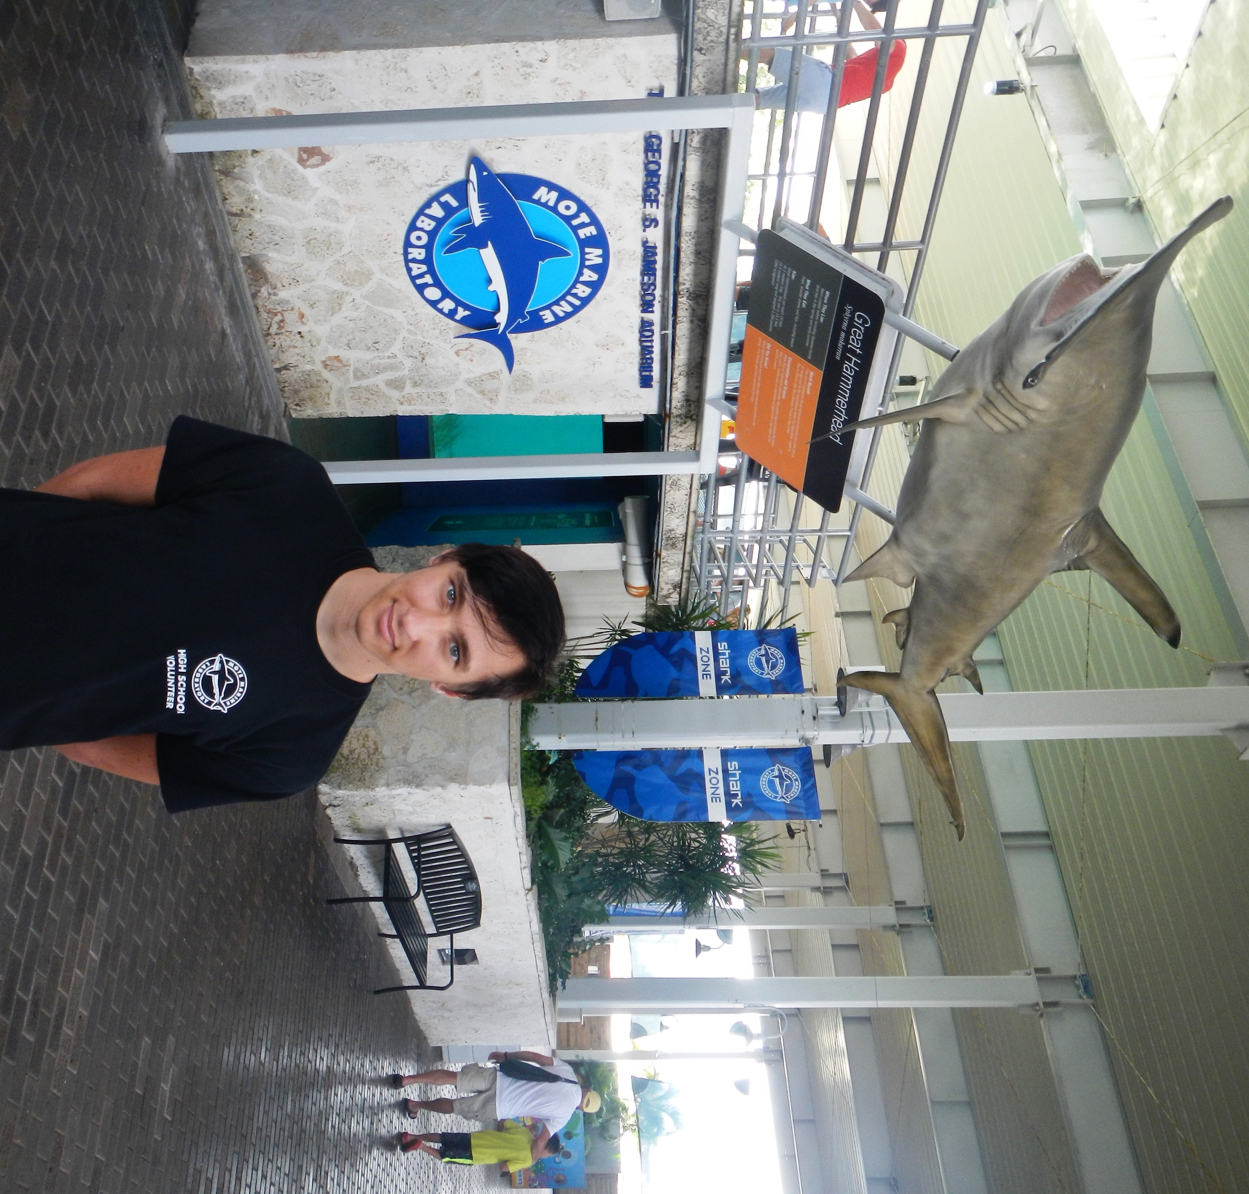

“I’ve been visiting Mote Marine Laboratory since I was a very young child and have always had a great fascination with marine life. Having grown up in Florida I have spent a great deal of time either in or near the water and have always enjoyed anything involving all types of nature and animals, especially those of marine origin and likeness. To be involved in Mote’s Summer High School Volunteer Program was only destiny.”

“Ever since I was old enough I have been going to the many camps that Mote Marine provides, from Aquakids to the Sea Sleuths, and then eventually graduating to the overnight camps in the Florida Keys. All of these wonderful programs taught me so much about the ocean and its many ecosystems and how everything is all tied together in this world. With the knowledge and passion that Mote Marine provided me, it was my turn to ignite this passion in others.”

“I became a high school volunteer in the summer of 2013, when I was entering 9th grade, after applying, being interviewed, and going through the training process of the program. After that I was assigned to the Friday morning shift which, at the time, was supervised by Tony Tabeek. Under his and my fellow volunteer’s guidance, I was taught great values of how to interact with our guests and what message we were trying to convey to our valuable visitors. By the end of that summer they commended me on being a hardworking, proactive, and valued member of the Friday morning team.”

“Over all my experience with the program has been very pleasant and valuable to not only my growth of knowledge, but also my personal growth. Under both the supervision of Tony Tabeek and Rick Magee I have been a proud and passionate member of the Mote’s volunteer team. Every Friday I arrive at my shift, I am very excited to help people learn something new and to hopefully inspire future generations of volunteers and marine biologists to join the cause to help us, as a whole, better understand and protect our vast and beautiful oceans.”

-- Nathan Rybicki, Junior at Venice High School

GALLERY

Spineless: Susan Middleton’s Mesmerizing Photographs

of Marine invertebrates
Excerpted from brainpickings.org

Visual verses celebrating the glorious grandeur of life on our pale blue dot.

The mystery of marine life has compelled humanity for millennia, from ancient India mythology to Aristotle, who was the first to outline the distinction between invertebrates and vertebrates in his Historia Animalium.
In Spineless, visual artist, educator, and explorer Susan Middleton turns her luminous lens to one particularly underappreciated aspect of these real and essential invisibilia: the exquisite and enigmatic world of marine invertebrates, which represent 98% of the known animal species in the oceans and are thus the backbone of life on our blue planet, on which 97% of the water is ocean.
Using a special photographic technique she developed, Middleton captures an astounding diversity of creatures, ranging from giant squid to tiny translucent jellyfish to two species new to science — the Kanola squat lobster and the Wanawana crab.
For Middleton herself, who has dedicated her life to capturing and conveying the realities of creatures quite different from ourselves — often ones gravely endangered by our human solipsism and the destructive entitlement it engenders — this has been a centerpiece of the project. To gaze at life forms with powers of perception so vastly different from — and often superior to — our own is to invariably ask what life is like for that being. Middleton puts this awareness beautifully:
This recognition has opened me to a larger world and a profound assemblage of energies beyond the human.
Each image is a visual verse that renders us a little more awake to the glorious grandeur of this world we share with so many other beings and a little more reluctant to contribute to its destruction with our small everyday choices.
Spineless is available in the Arthur Vining Davis Library
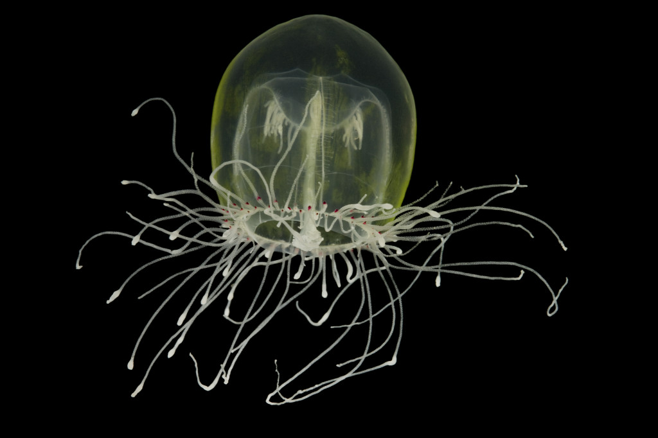
Red-eye medusa (Polyorchis penicillatus) © Susan Middleton

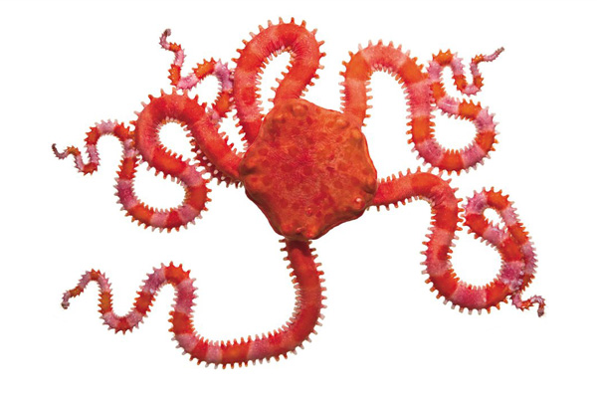
Pink brittle star © Susan Middleton
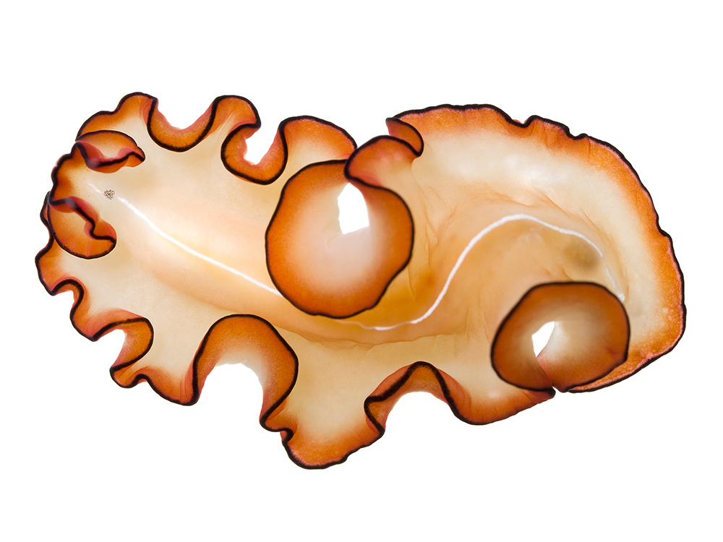
Orange-rimmed flatworm (Mayazoon orsaki) © Susan Middleton

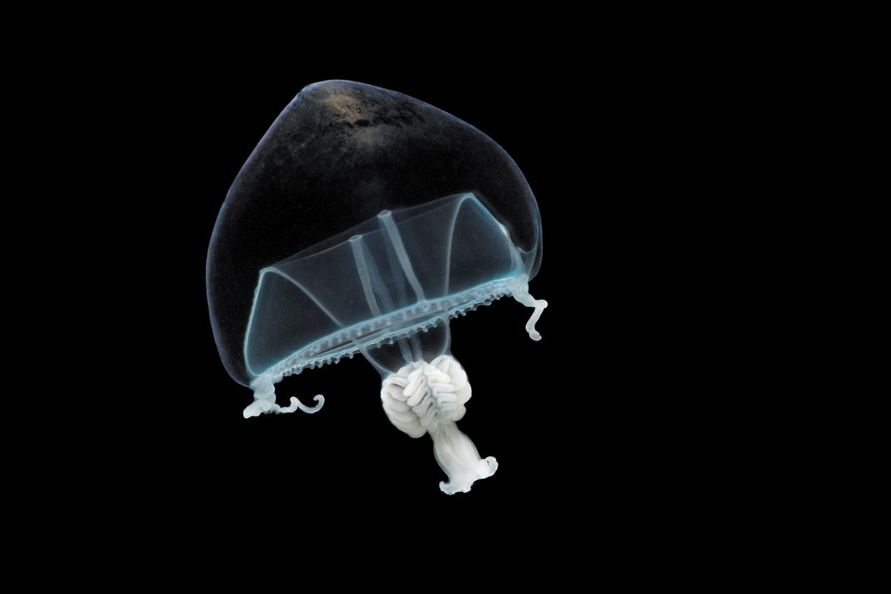
Hanging stomach jellyfish (Stomotoca atra) © Susan Middleton

