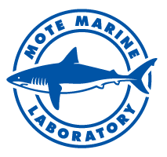

Green sea turtle nesting breaks local record, loggerhead nesting looks strong on Longboat Key through Venice

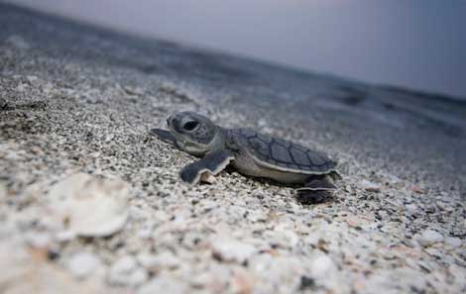

A green sea turtle hatchling makes its way to the ocean. (Photo credit: Marc Ellis, H2O pictures)

Hatchlings sometimes emerge in early morning, as shown above, but typically they emerge at night and use dim natural light to find the sea. It's important to keep beaches dark and clear of obstacles through the end of nesting season, Oct. 31.

Mote Marine Laboratory scientists are excited to share the encouraging, preliminary results of their annual count of Southwest Florida sea turtle nests.
During the 2015 nesting season that began May 1, Mote-monitored beaches from Longboat Key through Venice have hosted a record number of green sea turtle nests and potentially tied their past combined record for greens and loggerheads.
This year’s record for green turtles is confirmed, but loggerhead numbers and the grand total must be confirmed or updated following a thorough review of data once nesting season officially concludes on Oct. 31.
Nests in Southwest Florida continue to hatch, so it is important to keep beaches dark and clear of obstacles for hatchlings trying to reach the water throughout the season.
Mote’s Sea Turtle Patrol — a group of scientists, interns and volunteers who are monitoring nesting beaches for their 34th year on Longboat Key through Venice — report that 2015 brought a preliminary count of 2,433 loggerhead sea turtle nests and a confirmed count of 36 confirmed green sea turtle nests.
The 36 green sea turtle nests broke Mote’s previous record: 30 green turtle nests in 2013. In recent years, green turtle numbers around Florida have risen encouragingly. Statewide numbers are still being tallied, but so far, certain areas of Florida have reported exciting 2015 counts. (For example, USA Today reported recently on high green turtle counts from a wildlife refuge on Florida’s east coast, where greens are generally more prevalent. http://www.usatoday.com/story/news/nation/2015/09/01/green-sea-turtles-set-nesting-record/71528312/)
Adding up nests from green and from loggerheads, the more common species for Southwest Florida, Mote’s preliminary grand total is 2,469 nests. If confirmed, it will equal the record total that Mote reported in 2012.
“We’re really pleased that green sea turtles broke their local record this year and that loggerheads, and the overall total, might tie with their best year yet,” said Kristen Mazzarella, Senior Biologist with Mote’s Sea Turtle Conservation and Research Program. “Nest numbers have been quite strong here during recent years, reflecting increases elsewhere in Florida. We don’t know all of the reasons for these increases — there are many natural influences on sea turtle populations. However, we know that strong conservation measures instituted over 25 years ago, like the federal Endangered Species Act, state laws and local sea turtle ordinances are important, and we should never underestimate the positive impacts of local research, conservation and education efforts — like our 34-year program here at Mote.”
Nest counts for each sea turtle species by location are listed below. All loggerhead counts are preliminary.
 | Loggerhead |  | Green |  | Kemp’s ridley
 | Nests | False Crawls | Nests | False Crawls | Nests | False Crawls
Longboat-Manatee | 338 | 287 | 2 | 1 | 0 | 0
Longboat-Sarasota | 354 | 329 | 3 | 1 | 0 | 0
Lido Beach | 97 | 110 | 0 | 0 | 0 | 0
Siesta Key | 406 | 395 | 1 | 1 | 0 | 0
Casey Key | 984 | 885 | 29 | 20 | 0 | 0
Venice | 254 | 442 | 1 | 1 | 0 | 0
Totals | 2,433* | 2448* | 36 | 24 | 0 | 0

Notes:
- *Includes potential hawksbill/loggerhead hybrid turtle (details below).
- False crawls are cases in which a sea turtle emerges and then returns to sea without laying a nest.

One 2015 nest currently labeled “loggerhead” was sampled for genetic testing to double-check its parent species. Genetic tests conducted after the 2014 season revealed two nests from an unusual visitor: a hybrid loggerhead/hawksbill sea turtle. Mote scientists want to know if a hybrid has also visited this year.
Hybrids from loggerheads mating with hawksbills are uncommon, but not unprecedented, elsewhere in the world. Mote has never documented a hawksbill nesting in its patrol area and had never documented a hawksbill-loggerhead hybrid locally until 2014. It is unknown whether any have slipped “under the radar”; hawksbill tracks on the beach can resemble those from loggerheads, and scientists often must see a nesting turtle or hatchlings to suspect a hybrid. In 2014 a suspected hybrid mother was observed and the hatchlings and eggs from its two nests were determined to have genetic traits from both loggerhead and hawksbill sea turtles. It may be months before similar testing can be conducted for the unconfirmed, 2015 nest.
No matter their species, every hatchling matters. All sea turtle species are threatened or endangered, and they are protected by state and federal laws.
Mote’s multi-decade monitoring efforts providing data that resource managers can use to understand and protect sea turtle populations. Long-term data are particularly important because sea turtles are long-lived species. It takes about 30 years for hatchlings born on our beaches to return to nest as adults.
“We have our fingers crossed that the remaining local nests will hatch successfully and ultimately add more breeding adults to the sea turtle population in our region,” Mazzarella said. “In part, the end results of nesting season will depend on natural factors such as weather. Many nests successfully weathered the rain this summer, but some were washed out, and hurricane season is still ongoing. In addition, these turtles are quite vulnerable to human activity. Hatchlings are at risk of disorienting — or losing their way to the sea — because of artificial lighting visible from the beach.”
Female sea turtles and their hatchlings find the water by heading toward the brightest horizon. On a natural beach, the ocean horizon is brighter than the shore. On a developed beach, light from waterfront properties can disorient sea turtles and draw them toward roads, drains, yards, swimming pools and other dangerous locations, exhausting the energy they need for reproduction and survival.
Rescued hatchlings in Mote’s area should be reported immediately to Mote’s sea turtle researchers at 941-388-4331.

So far this year, the Hatchling Hospital within Mote’s public Aquarium has responded to about 2,200 hatchlings. About 450 of those needed to remain in the hospital for a period of time to help recover their strength.
“This was our highest number of patients in the Hatchling Hospital during the past six years,” said Holly West, Sea Turtle Care Coordinator at Mote.

Mote hosts 2nd International Workshop on Impacts of Ocean Acidification and Climate Change on Corals and Coral Reefs
By Kaitlyn Fusco

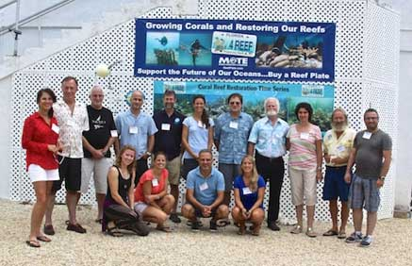

Researchers from seven nations gather for the 2nd International Workshop on Impacts of Ocean Acidification and Climate Change on Corals and Coral Reefs, which was lead by Mote Marine Laboratory.

The 2nd International Workshop on Impacts of Ocean Acidification and Climate Change on Coral Reefs was co-hosted by Mote Marine Laboratory and the Interuniversity Institute for Marine Sciences (IUI) of Eilat, Israel. The Workshop took place at Mote’s Tropical Research Lab in Summerland Key, Fla. from Aug. 25 – Sept.1, 2015 and brought together participants from Cuba, Israel, Jordan, Italy, Guam, the U.K. and the U.S.
The workshop allowed international scientists to collaborate in creating an ocean acidification experiment that is kicking off this month at Mote's Keys facility.
Ocean acidification (OA) is one of the greatest global threats to coral reef ecosystems. OA refers to the chemical reactions when carbon dioxide (CO₂) is absorbed by seawater. This causes a water chemistry change often called the “osteoporosis of the sea” because it is expected to weaken and even dissolve calcium carbonate structures such as coral skeletons and mollusk shells, and it may affect a wide array of other marine animals and ecosystems.
Research has shown that corals under increasingly acidic ocean conditions are more susceptible to “bleaching.” Coral bleaching occurs when corals become stressed due to high-temperature water and the symbiotic algae they depend on for some of their food leave the corals' tissue. Without their symbiotic algae, corals appear white in color, and this bleaching can eventually lead to coral death. Ocean acidification can also lead the calcium carbonate skeletons of coral to dissolve, causing destruction of coral reefs themselves.
“Passion for marine science and our partnerships with other institutions around the world have been primary pillars for Mote Marine Laboratory over our 60 year history that enable Mote to have a global impact on conservation and sustainable use of our shared marine environment,” said Dr. Michael P. Crosby, President and CEO of Mote. “Mote and the Inter-University Institute for Marine Science in Eilat, Israel, were pleased to co-host their 2nd International Workshop on Ocean Acidification Impacts to Coral Reefs, which fostered collaborative efforts among a diverse, international group of scientific experts to study Florida Keys coral reefs' resilience to ocean acidification and the potential for successful restoration of corals under declining ocean pH levels that can be applied to other ecosystems around the world.”
Dr. Emily Hall, Mote Staff Scientist and Manager of the Ocean Acidification Program, shared the same enthusiasm for the workshop.
“Ocean acidification is a real, global issue that is happening right now and there are many reasons for concern," Hall said. “We depend on our marine ecosystems for food, economy, medicine, tourism, art and quality of life. The impacts of ocean acidification are potentially detrimental to some of these things and the need for a solution to this problem is greater now than ever.”
The OA Program started at Mote with a small indoor OA system located at Mote's Summerland Key facility. From there, the Program added an outdoor system in the Summerland Key facility and an indoor system in Mote’s main Lab in Sarasota. After three OA workshops that Mote held in Sarasota (2012-2013) and one OA workshop in Israel with Dr. Maoz Fine at the IUI (2013), Mote scientists applied for a National Science Foundation (NSF) facilities grant to build upon the system in the Keys. Mote was awarded the NSF facilities grant for 2014/2015 and is currently making finishing touches on the system.

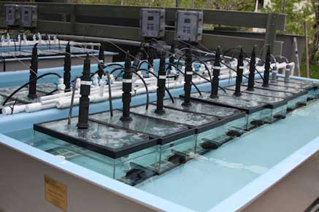

Mote's new Keys-based ocean acidification system, OAFTERU (Ocean Acidification Flow-Thru Experimental Units), which workshop participants will use for future mesocosm studies involving coral reef organisms from the Florida Keys to study how ocean acidification and climate change will affect the local ecosystems. (Credit Mote Marine Laboratory.)

“The impact of OA on coral reefs is significant and this workshop presents a good opportunity to learn more about these pressing issues. This partnership with Mote is important, because what is happening in the coral reefs here is associated with what is happening with coral reefs in Cuba. In Cuba, we don’t have the right resources to conduct this type of research. We can exchange knowledge and resources here at the workshop to make a difference,” said Pedro Alcolado Prieto Marine Biologist at Instituto de Oceanologia in Cuba.
“Ocean acidification is the hottest topic for coral reef researchers, because it is a major environmental concern. It is my goal to learn as much as possible during this workshop and work in collaboration with Mote Marine Laboratory, which is such a beautiful and incredible research facility, and others to make progress on this hot topic,” said Dr. Yehuda Benayhu, Professor at Tel Aviv University, Israel.
During the workshop, participants planned lab and field experiments with coral reef organisms from the Florida Keys to study how ocean acidification and climate change will affect the local ecosystems. Participants emphasized multi-year, reef community-based experiments geared toward providing research to better inform managers and policy makers. A mesocosm experiment, which hopes to provide reef community-based information under ocean acidification and climate change, will begin this month, and is based off of participant’s ideas and contributions. All participants will continue to contribute to the science of these mesocosm studies as they run for the next 12 months.
"It is incredibly important to start to design mesocosm experiments that answer questions about the impacts of ocean acidification on corals. I am most interested in determining how microbes interact with the coral host and even with other microbes. The beauty of these kinds of experiments is that they allow each of us to provide a missing piece of the puzzle,” said Dr. Kim Ritchie, Mote Senior Scientist and Manager of the Marine Microbiology Program.
A mesocosm is an experimental tool that brings a small part of the natural environment under controlled conditions. In this case, the group designed a mesocosm experiment utilizing Mote’s new Ocean Acidification Flow-Thru Experimental Raceway Units (OAFTERU) and corals from Mote’s nursery. The Ocean Acidification Program is fairly new at Mote, established in 2012 to research and understand responses of ecologically important species — like corals — to projected levels of ocean acidification.
The schedule for the weeklong workshop was full. After initial group discussions and breakout sessions, all participants left the classroom for some hands-on learning. Participants dove or snorkeled in Looe Key, as well as at Mote’s coral nursery nearby, to ensure everyone could experience a Florida Keys reef, and gain perspective. Since coral restoration under ocean acidification was also a topic of the meeting, participants saw the nursery where staghorn coral are propagated and raised for reef restoration. This also gave participants perspective and offered inspiration for creative thought and insight for discussions.
“This workshop is a unique opportunity that brings many members from all over the world to collaborate together to find solutions to a problem that affects us all, ocean acidification and climate change,” said Dr. Ali Al-Sawalmih, Research Assistant Professor at the University of Jordan. “This workshop brings people from all different nationalities together, enhancing future collaborations, which is important for the future of the environment.”
The researchers at the workshop also compiled published information to create a manuscript focusing on regional differences in ocean acidification rates of change, and identify areas of possible refugia, an area where special environmental circumstances have enabled a threatened species to survive, and determine how reef processes may be impacted by ocean acidification because of these regional differences.
“Ocean Acidification is a global problem,” said Dr. David Vaughan, Executive Director of Mote’s Tropical Research Lab in Summerland Key. “It was very important to have and international group of people to discuss multi-regional impacts and what we can do in these different areas. It brought people together from all over the world with different expertise, which will enable us to collaborate and work together on this global issue.”

About the Mote-Israel Partnership
The 1st International Workshop on Impacts of Ocean Acidification and Climate Change on Corals and Coral Reefs was co-hosted by Mote and the Interuniversity Institute for Marine Sciences (IUI) of Eilat, Israel and took place in Eilat.
Mote has a long history of research in Israel and collaborations with scientists there. Mote’s Founding Director, famous “Shark Lady” Dr. Eugenie Clark, conducted some of her early fish and shark research in the 1950s with colleagues in the Red Sea.
In 2014, Mote and the IUI in Eilat, Israel signed a memorandum of understanding (MOU) that has led to new research endeavors designed to understand the impacts that climate change and ocean acidification will have on coral reefs and find ways to restore and protect reefs worldwide. The MOU builds upon the Mote-Israel Cooperative Marine Research Program, which supports research initiatives benefitting the environments of both nations.
Mote’s President and CEO, Dr. Michael P. Crosby, has worked closely with top Israeli researchers since 1994. Crosby is also a former chairman of the United States-Israel Binational Science Foundation Board of Governors and has served on the Board since he was appointed by the U.S. State Department in 2002.

About the Mote-Cuba Partnership
Beginning in the last century, Mote scientists have built relationships with the National Aquarium of Cuba and a diversity of marine researchers in other Cuban institutions, which have formed the foundation of the U.S.-Cuba-Mexico Trinational Initiative for Marine Science and Conservation in the Gulf of Mexico and Western Caribbean. This partnership conducts joint research and monitoring of key species and threats to the Gulf of Mexico’s and Western Caribbean's biodiversity and critical habitats.
Cuban marine scientists and students work closely with Mote coral researchers through workshops that bring Cuban coral reef scientists to Mote’s field and main labs in Florida. Mote. Scientists from Mote’s Shark Biology & Conservation Program have worked with scientists from the National Aquarium of Cuba, University of Havana and other Cuban organizations for more than 10 years to address key questions about shark behaviors in Cuba.
About the Mote-Jordan Partnership
Mote Marine Laboratory and The University of Jordan (UJ) in Aqaba, Jordan signed a memorandum of understanding (MOU) in 2011 to establish and broaden exchanges and scientific cooperation in the field of marine sciences, particularly as it pertains to promotion of sustainable use of marine and costal resources in the Gulf of Aqaba, the Gulf of Mexico and the Florida Keys. Areas of significant interest to both Mote and the UJ include ecology of fishes, corals and other marine invertebrates.
A major focus of UJ is to expand the capabilities of the Marine Science Station and enhance the growing research and education programs of the faculty of the marine sciences that address critical needs of Jordan’s only marine ecosystems.
Mote’s President and CEO, Dr. Michael P. Crosby, has led U.S., Israeli and Jordanian partners in the Red Sea Marine Peace Park Cooperative Research, Monitoring and Management Program — an effort to protect coral reefs that support thousands of species in the Gulf of Aqaba.

Ocean Acidification Roundtable highlights emerging challenge for Florida waters
By Hayley Rutger

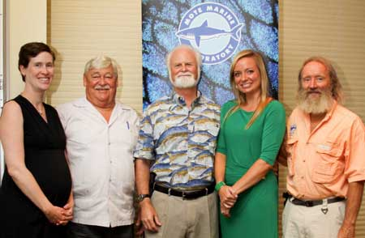

Marine science, management and policy leaders at the Ocean Acidification Roundtable. From left: Dr. Sarah Cooley of Ocean Conservancy, Dr. Billy Causey of NOAA, Dr. Michael P. Crosby of Mote Marine Laboratory, Florida Rep. Holly Raschein, and Dr. David Vaughan of Mote.

An “invisible” threat has begun to harm Florida’s marine resources — but the Sunshine State has unique strengths and opportunities to respond — said scientists, government officials and other key stakeholders Wednesday during a statewide roundtable on ocean acidification.
The roundtable — hosted by Mote Marine Laboratory and Ocean Conservancy at Mote’s campus in Sarasota, Fla. — wove together the latest scientific knowledge; fostered collaborations among researchers, resource managers, community environmental leaders, legislators and industry representatives; raised questions for local, state and regional planning; and will benefit others in Florida and beyond through a special report expected in the coming weeks.
Ocean acidification (OA) is occurring due to increased levels of carbon dioxide in the atmosphere, some of which enters the ocean, making seawater acidify. OA could cause substantial changes to the ocean, and as a result, affect people and communities that depend on a healthy ocean.

“Mote is first and foremost a research and science-education organization, and we don’t take sides in politics or advocacy issues — however, we know one thing that is irrefutable from the data: A healthy blue environment is vital to the quality of life and the health of the economy in Florida, and marine resources all around the state are vulnerable to ocean acidification,” said Dr. Michael P. Crosby, President & CEO of Mote.
One vulnerable treasure is Florida’s barrier coral reef, which helps attract millions of visitors, supports vital fisheries and ecotourism, protects against storm surges and contributes about $6.3 billion to the state’s economy. Research by Mote and others shows that coral reef organisms — including threatened and endangered corals of the Florida Keys — can have a harder time growing and building their carbonate-rich skeletons as waters acidify. Lab experiments have shown that OA conditions can hinder key steps in producing the next generation of federally protected elkhorn corals.
“As an avid diver, I have seen firsthand the beauty of coral reefs and the abundance of organisms that call these reefs home — and as the mother of a young son, it is important to me that our coral reefs are thriving for him and for future generations to enjoy,” said Rep. Holly Raschein, R-Key Largo, who spoke at the roundtable and has dived with Mote scientists at their Keys-based, coral restoration nursery. She praised roundtable participants for working to study and address OA impacts that threaten Florida’s underwater resources.
“I applaud the leadership of Mote Marine Laboratory in bringing together a cross section of Florida’s marine scientists and representative from diverse stakeholder groups to discuss a statewide approach for research to address ocean acidification impacts,” Raschein said. “What Mote, the Ocean Conservancy, and all of you are doing today will help translate and transfer the science and knowledge of ocean acidification to the broader public. It will also help legislators better understand the importance of supporting the restoration and enhanced resiliency of Florida’s marine resources.”
“We wanted to foster and expand the great conversation already taking place in Florida,” said Dr. Sarah Cooley, Science Outreach Manager at Ocean Conservancy. “This roundtable has shown us that there is a lot of energy to address ocean acidification here, and that momentum is going to take ocean acidification science out of the research space and allow for action.”
Roundtable highlights
- OA is here, now.
Outside the research community, OA might seem an obscure or distant threat. However, it is already beginning to affect Florida’s natural resources.
For instance, coral reefs in some northern areas of the Florida Keys have experienced notable dissolution of their calcium carbonate structures during winter, possibly because colder months mean less seagrass to absorb carbon dioxide. This impact is occurring 30-40 years sooner than expected by some scientific predictions, but early predictions have mainly used open ocean data — and OA may operate differently in shallow, coastal waters. This effect is seasonal now, and some reefs in the Keys are still doing well, but impacts may increase as waters acidify.
“The implications could be far reaching,” said Dr. Billy Causey, Southeast Regional Director for the National Marine Sanctuary Program of the National Oceanic and Atmospheric Administration. “There are so many carbonate organisms on the reef. Whether it’s coral or calcareous algae or the lobster we think about so much, so many living things have calcium carbonate in their bodies.”
Shellfish beds are a key resource affected on the Pacific coast and potentially vulnerable in Florida.
It remains unknown whether or how OA might impact other habitats and structures around Florida’s coast, including the carbonate-based geology that underlies reefs and land-based structures.
- OA isn’t happening in a vacuum.
Florida’s natural resources face multiple threats. For instance, coral reefs can become stressed by warming temperatures — another consequence of increased carbon dioxide in the air and water — along with pollution, storms and other impacts. Stressed corals may be more susceptible to one of the top threats: disease.
- Marine life may be “winners” or “losers”
OA impacts may vary among different species of marine life or genetic strains within a species. Studying these differences is critical for maintaining and restoring marine ecosystems.
For example, Mote has raised thousands of corals for reef restoration efforts based at its Florida Keys campus, and Mote scientists are currently studying which genotypes of threatened staghorn coral might fare best amid OA and other stressors.
- OA knowledge and goals must be shared through clear, concise messages so that Florida communities and decision makers can respond wisely.
Part of the challenge is highlighting an “invisible” threat.
“If carbon dioxide had been orange in color and smelled like rotten eggs, things would be different,” said Dr. Dave Vaughan, Manager of the Coral Reef Restoration Program at Mote. “If you tell people there is carbon dioxide affecting the oceans by lowering pH, they may not think of it the same way they think of an oil spill or another visible concern. But maybe the current research can drive home that OA is a reality today and not just a concern for the future.”
Roundtable participants discussed how to better share scientific findings in helpful ways, such as producing unified communications materials, synthesizing meaningful research results, highlighting the economic value of resources at stake.
Supporting OA research through public and private funding, particularly through philanthropic giving, is essential for addressing this threat.
- Florida is already rich in OA data and environmental monitoring programs. Future efforts can piggyback.
“There’s a lot of good baseline data in the literature and deep down in the records from state and federal agencies, counties and research institutions – pH, alkalinity, temperature, salinity, calcium, nutrients, paleo-biology and paleo-climatology,” said Dr. Erinn Muller, Manager of the Coral Health and Disease Program at Mote. “Scientists need to step back and synthesize this data to show the story of what’s already happening with Florida ecosystems.”
Roundtable participants suggest both analyzing the available data and conducting more research to understand key concepts like how OA varies through time and space, and which keystone or iconic marine animals might be affected.

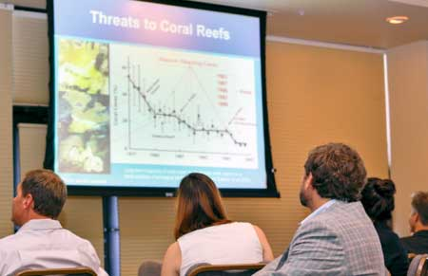

Threats to coral reefs and other economically valuable Florida resources were discussed at the Sept. 2 Ocean Acidification Roundtable at Mote Marine Lab.

(Credit both photos to Mote Marine Lab.)

We can be optimistic.

Florida may host habitats that naturally buffer OA impacts. For instance, scientists have begun to study possible benefits of increased seagrass beds, which sequester carbon dioxide (like trees do).
In addition, scientists, policymakers, industry representatives and others have shown great interest and energy for addressing OA in Florida, and there is enough knowledge to act now.
For example, the recently introduced federal bill HR 2553: the Coastal Communities Acidification Act of 2015, has the support of 10 Florida representatives. This bill would require federal officials to study the vulnerability of coastal communities in Florida and around the country to ocean acidification.
“We should use the best available science now to begin mitigating the impacts of ocean acidification by implementing major coral restoration initiatives. The lack of 100-percent scientific certainty of outcomes should not paralyze us from addressing critical impacts to ecosystems and organisms that are happening now,” Crosby said.

UPCOMING EVENTS

Oct. 3: Support Mote at second annual masquerade gala
Enjoy an enchanted evening full of dancing and mystery while supporting Mote Marine Laboratory at the second annual masquerade gala, Bal Masqué: Midnight in the Garden of Good and Evil. The gala takes place Saturday, Oct. 3 from 8 p.m. to midnight at the Sarasota Opera House, 61 N. Pineapple Avenue Sarasota, Fla., 34236.
Guests will wear their most elegant formal attire and creative masks. The Sarasota Opera House will be transformed into a mysterious garden where beautiful musical performances will set the tone for the night, aerialists will entertain from the vaulted ceilings and dancers will take stage. Cocktails and bite-sized food will be available throughout the night.
Tickets are $125. For each individual Bal Masqué ticket purchased online, SRQ | The Magazine will donate a portion of the proceeds to one of seven local organizations, including Mote, an independent, nonprofit marine research and education institution comprised of world-class marine scientists committed to the conservation and sustainable use of our oceans. Guests can select Mote Marine Laboratory from a list on the drop down menu on the purchase page.
Get ready for a mesmerizing night at the Harlequin Club VIP Party at Saks Fifth Avenue hosted by Sophie’s from 6:30 p.m. to 8 p.m. The Harlequin Club provides exclusive access to Bal Masqué including tickets to the gala, a VIP lounge, private bar access and more. For each individual Harlequin Club ticket purchased online, SRQ | The Magazine will donate a portion of the proceeds to one of seven local organizations, including Mote. Guests can select Mote Marine Laboratory from a list on the drop down menu on the purchase page.

To purchase your Bal Masqué or Harlequin Club tickets visit www.SRQBalMasque.com
Volunteers needed at Mote:
Learn more at free coffee reception

PLEASE SHARE THE INFO BELOW WITH FRIENDS AND FAMILY
Learn about exciting volunteer opportunities at our free coffee reception at Mote Marine Laboratory & Aquarium.

Where: Mote Marine Laboratory & Aquarium WAVE Center
1600 Ken Thompson Parkway (City Island, Sarasota)
When: Wednesday, October 7th, 9:00-11:00

For more information and to RSVP for the reception ,
contact Robert Rogers at volcoordinator@mote.org / 941-388-4441 x852
Volunteer General Meeting in Sea Cinema Thursday, October 8th 9:00-11:00 Presents: Ocean Technology with Guest Speaker Dr. Jordon Beckler

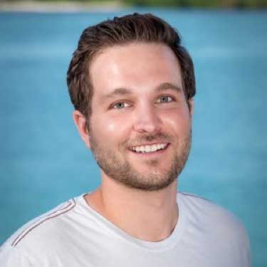

Dr. Jordon Beckler joined the Mote Ocean Technology group in February of 2015. He earned a Ph.D. in chemical oceanography with a minor in inorganic chemistry at Georgia Tech, where he researched the redox cycling of metals and sulfur using in situ electrochemical analyzers and HPLCs during his dissertation research. He has extensive field experience on oceanographic research cruises and has had the opportunity to explore hydrothermal vents and other deep-sea environments with DSV ALVIN and other ROVs. At Mote, Jordon manages the SO-COOL Harmful Algae Bloom monitoring network of optical phytoplankton detectors and coordinates deployments of Slocum gliders around the Gulf of Mexico.
He also brings some exciting new projects to the Ocean Technology program:
1) developing techniques to use in situ HPLCs to measure red tide toxins
2) evaluating the potential for iron flux from sediments to initiate red tide blooms on the West Florida Shelf. In his free time he enjoys surfing, fishing, and exploring the oceans with his home-built ROV.

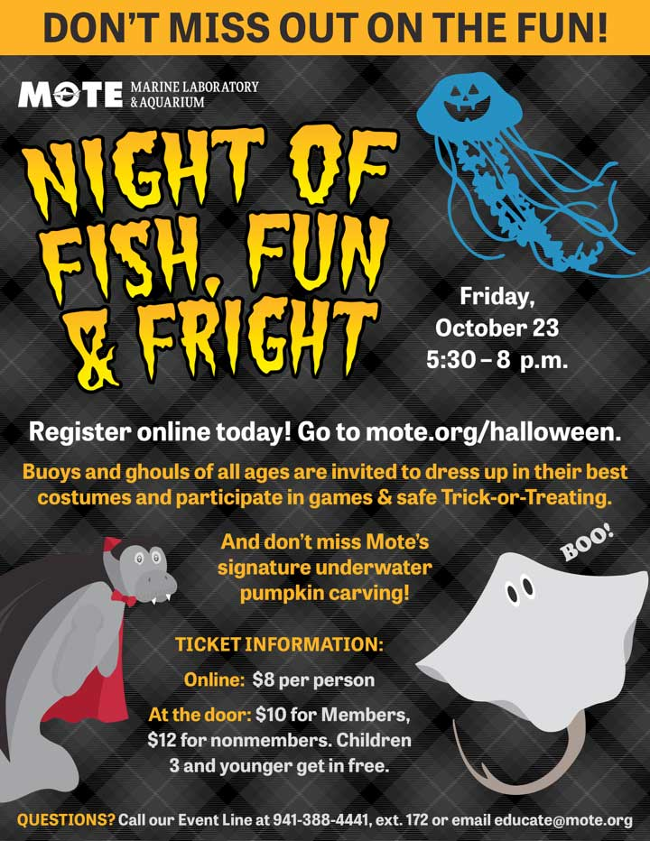

“ One of the nicest things about life is the way we must regularly stop whatever it is we are doing and devote our attention to eating.” - Luciano Pavarotti
** Save the Date * *
October 22, 2015 at 6PM
The Mote Volunteer Association presents:
Italian Night at Mote

Come join your fellow volunteers at a new theme party for Mote volunteers & spouses

Italian Pasta Dishes! Italian Salads! Italian Bread! Italian Music! Italian Slideshow!

And a new and exciting way to meet your fellow volunteers and make new friends!

Please contact volcoordinator@mote.org for details.

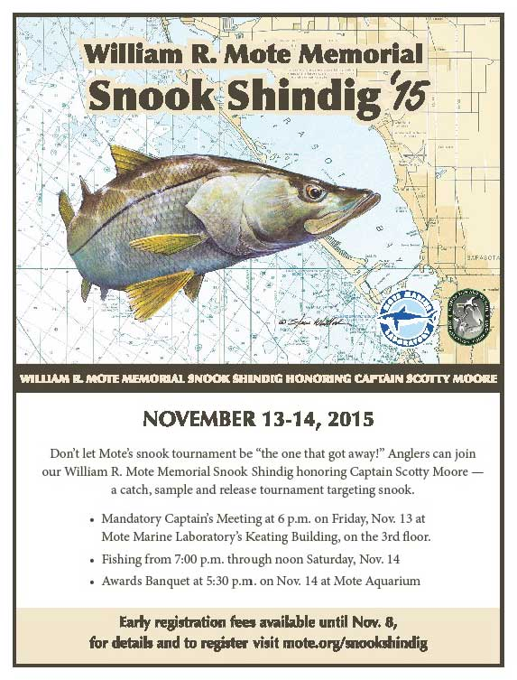

VOLUNTEER OPPORTUNITIES
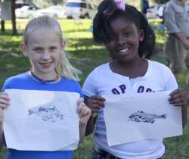
Mote Teach-A-Kid-Fishing Clinic (Saturday, November 7)

Kids Fishing Clinic-
Date/Time: Saturday November 7; 9 a.m. to 12:30
Lunch: (included) Sponsored by Sarasota Sportsmens Association
Location: Mote Aquaculture Research Park, 12300 Fruitville Road, Sarasota, FL (7 miles East of I-75).
Ages: 5-16 (plus parents/guardians); Limit 120 children
Cost: $10.00 per child
We will have the following educational stations:
1) (a) Spin casting, (b) Fly casting;
2) (a) Bait and Tackle, (b) Ethical Angling
3) (a) Gyotaku Fish Printing, (b) Kayak Demonstration
4) Fly Tying
5) Pond Fishing
6) Tours of MAP
The stations will be 30 minutes with # 1-3 split 15 minutes each.
Event Jobs:
- Registration Check -In and End of Event check-out (provide rod and reel, bait and tackle box, certificate of accomplishment, and a reusable bag of educational and fun items. We just received sponsorship this weekend for t-shirts so we can provide one to each child.
-Professional guides, anglers, and those interested to help at each station.
-Group leaders to be with each group through each station to move people in a timely manner.
-Set-up the day prior to event Friday November 6.
Please also pass the word to let families know. The sign up for children should be online by next Monday.
William R. Mote Memorial Snook Shindig 2015
honoring Captain Scotty Moore

Date: November 13-14, 2015
Location: Mote Marine Lab on City Island Park
Captains Meeting: Friday November 13, 6:00
Awards Ceremony: Saturday November 14, 5:30-9:00
Fishing Location: Sarasota Bay from Cortez to Venice.
Background:Special catch, sample and release tournament to help document contributions to the fishery of our hatchery reared snook tagged and released into Sarasota Bay. Stocked snook, tagged with coded wire tags before release into Sarasota Bay, are the focus of pilot studies to identify stock enhancement potential and the best release strategies. Snook caught during the tournament are checked by Mote researchers, who recover tag data and use the information to adjust release protocols. Our past research tournament results documented that the stocked hatchery-reared snook are contributing to the fishery in Sarasota Bay and changes in snook release strategies based on the results of these pilot studies have improved survival of our stocked snook by as much as 200%. The Snook Shindig provides outreach to help the community learn more about Mote fisheries research and fish conservation, and to gather additional evidence about hatchery snook contribution rates in the fishery and about snook population size and movements in Sarasota Bay. The results are published in scientific journals. Visit the Science Consortium for Ocean Replenishment for current publications on Motes snook stock enhancement research in Sarasota Bay. (http://www.StockEnhancement.org).

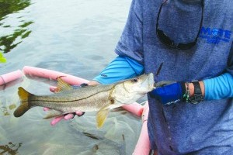
PLEASE CONTACT CAROLE NEIDIG AT
cneidig@mote.org / 941-704-7663.

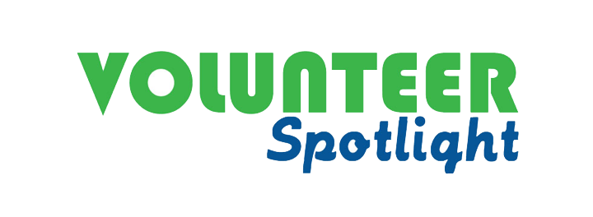

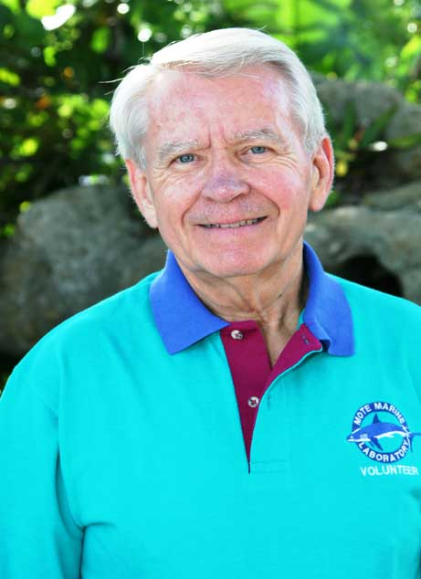

THE FORK IN THE ROAD by Joe Mathis
"If you come to a fork in the road, take it."

This quote, attributed to Yogi Berra, came to mind as I pondered my stressful transformation from a career to retirement, my two-year struggle to reinvent myself, and my ultimate discovery of a new sense of purpose in volunteering.
Retirement proved to be most disruptive. My challenging and rewarding career as an agricultural economist and dairy industry leader was over. I still had (and have) a loving wife and family, good health, and stimulating hobbies. Nevertheless, there was a void in how I defined myself and, in particular, what provided me with a sense of purpose and self-worth. Filling that void proved frustratingly elusive being further complicated by our relocation to a new home in a distant state. I faced the task of reestablishing an identity, renewing a sense of purpose, and forming new relationships with others.
My long search ended quite unexpectedly. A fellow Rotarian suggested that I might enjoy volunteering at Mote Marine Laboratory and Aquarium. As a recreational SCUBA diver, I had developed a fondness for life in the sea, but never contemplated adopting that interest as an avocation - particularly as a volunteer. Nevertheless - and thankfully - I took that "fork in the road."
I studied basic marine science, became an aquarium docent, then a guide trainer, a laboratory guide and a member of the lab's Speakers Bureau. The retirement void is filled with teaching others about the mysterious life beneath the sea and an appreciation for the wonders of nature. My sense of self-worth is restored, and I feel that I am making a difference in the lives of others.
The lessons learned
- Transformation from a career to retirement can be disruptive.
- Navigating the "fork in the road" in retirement is often difficult.
- It is important to keep an open mind and remain receptive to new suggestions and ideas.
- Once chosen, pursue the new "fork" with vigor.
- As Yogi correctly observed, "It ain't over 'til it's over."

GALLERY

Creepy Critters: Marine Life Surfaces for Halloween
Claws, spines, spikes, tentacles & fangs. Aliens, monsters, and ghostly apparitions glowing in the night. Marine life forms have some of the best looks for Halloween-no costumes needed. From freaky fish lurking beneath the surface to creepy crawlies of the deep, meet some the sea’s strangest and most haunting creatures.

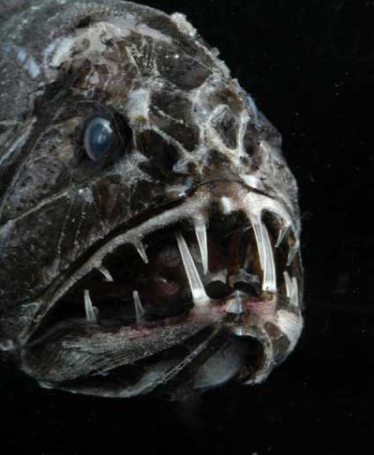

Fangtooth Fish (Anoplogaster cornuta)
The aptly named fangtooth fish has long, menacing teeth. The fangs are so long, that they aren't able to close their mouths! They are able to eat crustaceans and fish, despite the large teeth. But this "monster of the deep" is not as scary as it may seem--it only reaches about 17 cm (6 inches) in length.
Credit: © David Shale

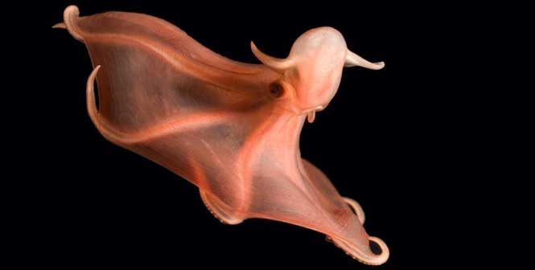

Glowing Sucker Octopus (Stauroteuthis syrtenis)
This billowing red octopod would be a sight to see in the dark of the deep sea. Its rows of suckers flash on and off with bioluminescence as it uses the netting in between its eight arms to swim in the ocean off the eastern U.S. Although the species was known for at least 100 years, it wasn't until 1999 that researchers realized it glowed.
Credit: © David Shale

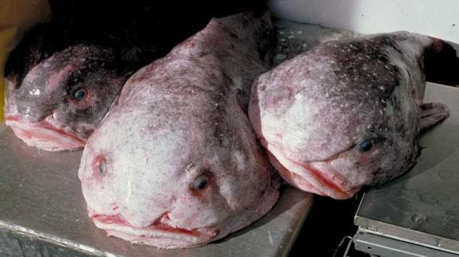

Blob Sculpin (Psychrolutes marcidus)
The ghoulish blob sculpin, a deepwater fish that can be found off the Pacific coast of the U.S., is reminiscent of a famous terrestrial monster from 1950s horror film classic "The Blob."
Credit: NOAA, Alaska Fisheries Science Center

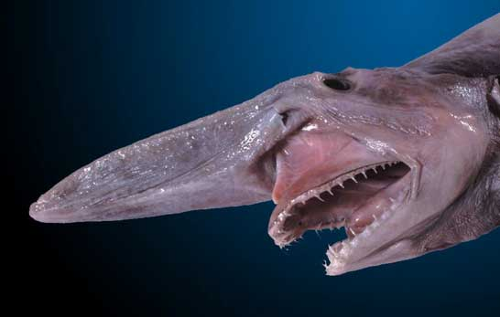

The Goblin Shark (Mistukurina owstoni)
The goblin shark is one of the creepier fish out there! It has a long, prominent snout covered with special sensing organs (ampullae of Lorenzini) that help it to sense electric fields in the deep, dark water it calls home. But even stranger is its jaw, which can be extended to the length of its snout to help the goblin shark ambush fish, squid and crustaceans.

Credit: Dianne Bray / Museum Victoria
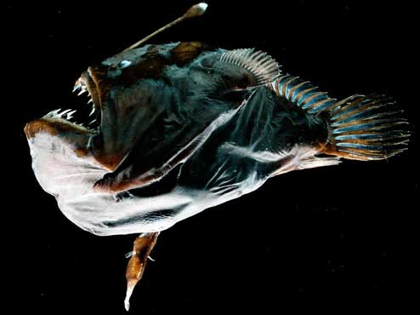

Blackdevil Fish (Melanocetus Johnsonii)

Blackdevil fish are quintessential monsters from the deep. The female lurks in the dark, drawing in prey with her glowing lure, while the male attaches to her like a blood-sucking parasite.

Credit: E. Widder, ORCA (www.teamorca.org)

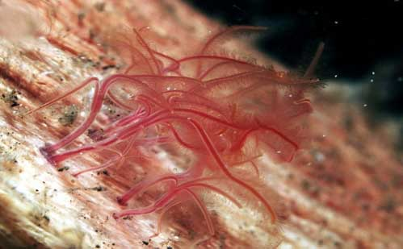

Zombie Worms (Osedax roseus)
Zombie worms may be tiny, at only 1 to 3 inches long, but they eat away at the bones of large dead whales on the deep-sea floor. They eat differently than we do though. With no mouth or anus the worms make an acid that dissolves the bones and they absorb nutrients with the help of a symbiotic bacteria.
Credit: Yoshihiro Fujiwara/JAMSTEC
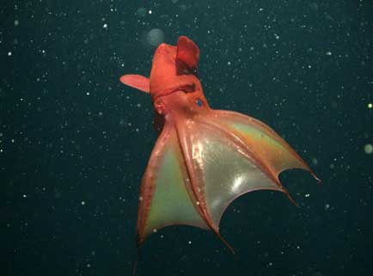

The Vampire Squid (Vampyroteuthis infernalis)
With a scientific name that means "the vampire squid from hell," you'd expect the vampire squid
to be a fearsome predator terrorizing the deep. Despite its demonic look, that isn't the case; instead, the vampire squid collects and eats drifting particles called "marine snow" using two long, sticky filaments. It doesn't seem like much food to fuel a foot-long cephalopod, but it's enough for it's slow lifestyle in dark, low-oxygen water with few predators.
Credit: (c) 2004 MBARI

OPEN TO ALL VOLUNTEERS

FALL 2015 BASIC MARINE SCIENCE COURSE

WHAT: An introductory course with emphasis on the local marine environment, Mote Research Programs, and the Aquarium. This course is for registered Mote volunteers only. This course is a training requirement for all Aquarium guides. The course is highly recommended for all other Mote volunteers. The Volunteer Manual will be used at MOST sessions and the assigned pages should be read before each lesson. A copy may be purchased for $25 (NOT A REQUIREMENT TO PURCHASE MANUAL).
WHEN: The classes will be held from Oct. 12 – December 2 from 9:00 a.m. until approximately 11:30 a.m., unless otherwise noted.
WHERE: WAVE Center (formerly Sea Cinema), unless otherwise noted.
QUESTIONS: Contact Volunteer Office at 941-388-4441, ext. 438 or ext. 852 or volcoordinator@mote.org

MONDAY, OCT. 12- ORIENTATION & CAMPUS TOUR
Bob Cameron, Volunteer Board President & Volunteer

WEDNESDAY, OCT. 14– PHYTOPLANKTON ECOLOGY
Dr. Vincent Lovko, Program Manager of the Phytoplankton Ecology Program

WEDNESDAY, OCT. 19 – MARINE & FRESH WATER AQUACULTURE RESEARCH
Dr. Kevan Main, Mote Senior Scientist and Marine & Freshwater Aquaculture Research Program Manager

WEDNESDAY, OCT. 21 – HOW HEALTHY ARE THE NATIONS WATERS?
Dr. Michael Barbour, Mote Marine Laboratory Adjunct Scientist

MONDAY, OCT. 26 - MANATEE RESEARCH/ MARINE CONSERVATION (273-294)
Dr. John Reynolds, Manatee Research Program Manager and Director of the International Consortium for Marine Conservation

WEDNESDAY, OCT. 28 – FISH HEALTH AND CARE & SHARK FEED
Evan Barniskis, Assistant Vice President for Aquarium & Biologist Staff

MONDAY, NOV. 2 - DOLPHIN, WHALE AND SEA TURTLE HOSPITALS/STRANDING INVESTIGATIONS
Lynne Byrd, Rehabilitation and Medical Care Coordinator, & Gretchen Lovewell, Program Manager & Rebeccah Hazelkorn, Staff Biologist - Stranding Investigations

WEDNESDAY, NOV. 4 – WILD DOLPHIN RESEARCH (294-306)
Dr. Randy Wells, Dolphin Research Program Manager

MONDAY, NOV. 9 – CORAL REEF ECOLOGY & MICROBIOLOGY
Erinn Muller, Mote Staff Scientist

WEDNESDAY, NOV. 11 – INTERPRETATION TECHNIQUES
Dana Henderson, School Programs Coordinator

MONDAY, NOV. 16 - BONY FISHES (213-272)
Mandy Wrobel, Public Programs Coordinator

WEDNESDAY, NOV. 18 - SEA TURTLE RESEARCH (273-285)
Kristen Mazzarella, Sea Turtle Research and Conservation Program Manager

MONDAY, NOV. 23- ARTHROPODS (131-158) & MOLLUSKS (89-124)
Kasey Gaylord-Opalewski, Sea Trek Coordinator // Educator Jason Robertshaw, Digital Learning Developer

WEDNESDAY, NOV. 25–MARINE HABITATS (41-62): THE GOOD, THE BAD & THE UGLY
Tommy Vaughan-Birch, Volunteer and Master Naturalist

MONDAY, NOV. 30 - THE AQUARIUM'S MANATEE RESIDENTS & RESEARCH (308-313)
Kat Boerner, Supervisor of Manatee Research//Laura Denum, Supervisor of Manatee Care

WEDNESDAY, DEC. 2 – ELASMOBRANCH REPRODUCTION AND BIOLOGY (177- 212) Dwight Davis, Volunteer & Dr. Carl Luer, Senior Scientist, Biomedical Research Program

